3.7 Module Test Results — Selenium
Bundoora Family Clinic — Digital Prescription and Medication Tracking Management System (DPMTMS)

3.7.1 Purpose and scope
This section reports the automated functional testing of the DPMTMS web application with Selenium WebDriver. Every test case has a unique ID, is traced to the functional requirements (FR1–FR50) and to the components in Section 2.6, and was executed against the running application (HTML/JavaScript front end, PHP JSON API and a MySQL-compatible database built from database/bundoora_clinic.sql). The actual result, pass/fail status and a screenshot are recorded for every test. Only the synthetic demo accounts and synthetic test data were used, in line with Section 3.2.

3.7.2 Responsibilities
Section | Assigned work | Member
3.7 | Set up Selenium framework, prepare test cases and unique test IDs | Utsav
3.7 | Execute Selenium tests — Group 1: Authentication, Account & RBAC (BFC-SEL-AUTH)
3.7 | Execute Selenium tests — Group 2: Doctor, Prescription & AI Safety (BFC-SEL-DOC)
3.7 | Execute Selenium tests — Group 3: Patient Portal & Pharmacy Matching (BFC-SEL-PAT)
3.7 | Execute Selenium tests — Group 4: Pharmacist, Dispensing & Inventory (BFC-SEL-PHM)
3.7 | Execute Selenium tests — Group 5: Administration, Reports, Security, Shortage & Recall (BFC-SEL-ADM)
3.7 | Review and combine all Selenium module test reports

3.7.3 Selenium framework and test environment
Item | Configuration used
Test tool | Selenium WebDriver 4.35.0 (Java bindings), Java 21 (OpenJDK 21.0.10)
Browser / driver | Chromium 141 (headless, 1440×1000 window) driven by ChromeDriver
Application under test | bundoora-family-clinic-html served at http://127.0.0.1:8080/bundoora-family-clinic-html/ by PHP 8.4 (built-in web server)
Database | bundoora_clinic imported from database/bundoora_clinic.sql + database/add_login_session.sql into a MySQL-compatible server (Dolt 2.3.5); reset to the clean import before the final run
Accounts | admin@bundoora.test, doctor@bundoora.test, patient@bundoora.test, pharmacist@bundoora.test, plus users created by the tests (selenium<n>@bundoora.test)
Design | One runner (Suite.java) with shared helpers (login per role, explicit waits, toast capture, confirm-dialog handling) and one method per module group (Tests.java). Tests run in order so that data created by one group (e.g. a new prescription) is used by the next (verification and dispensing).
Locators | Element IDs and names from the pages, e.g. #loginForm, #registerForm, #patientSelect, #medicineRows, #runSafetyBtn, #dispenseForm, #batchForm, #recallForm, [name=session_timeout], [data-dose], [data-delete-user]
Waits / evidence | Explicit waits (12 s) for asynchronous fetch() calls; a screenshot is saved after every test (Appendix 3.7-A); results written to results.tsv
Final run | 21 September 2026, 15:36–15:43 (UTC+5:45), one full uninterrupted run of all 66 tests

Note: the run used PHP’s built-in server in place of Apache and a MySQL-compatible engine in place of MariaDB/XAMPP. The front end, PHP code and SQL schema were used exactly as supplied. The OpenAI key in backend/secrets.php was detected (“AI API ready”), but external access to the OpenAI service was blocked in the test environment. Test BFC-SEL-DOC-12 therefore checks the local safety rules and the fallback message, not a live AI response.

3.7.4 Test ID convention
Test IDs use the format BFC-SEL-<Module>-<NN>, where Module is AUTH, DOC, PAT, PHM or ADM, and NN is the sequence number. The same ID is used for the screenshot file, the results log and the defect log.

3.7.5 Module test cases and results

3.7.5.1 Group 1 — Authentication, Account & RBAC
Assigned to: | Executed: 2026-09-21 | Result: 15 passed, 0 failed of 15
Test ID | Test case | FR | Steps / test data | Expected result | Actual result | Status
BFC-SEL-AUTH-01 | Register new patient with valid details | FR1, FR2, FR7 | register.html: full name, unique email, phone, DOB 1995-05-10, address, password Test@1234 ×2; submit #registerForm | Account created with Patient role; demo OTP shown; redirect to otp.html | Status: "Registration created. Local demo OTP: 700956. Redirecting to verification…". Redirected to otp.html. | Pass
BFC-SEL-AUTH-02 | Registration rejects mismatched passwords | FR2 | Password Test@1234, confirm Other@1234; submit | "Passwords do not match." shown; no user record created | Error shown: "Passwords do not match.". Records created in users table: 0. | Pass
BFC-SEL-AUTH-03 | Registration rejects duplicate email | FR2 | Register again with patient@bundoora.test | Error shown; still only one account with that email | Error shown: "Database operation failed". Accounts with this email: 1; page stayed on register.html. | Pass
BFC-SEL-AUTH-04 | Registration rejects invalid email / blank required fields | FR2 | Email "abc", full name blank; submit | Browser validation blocks submission; stays on register.html | Browser validation blocked submission (form valid=false); first invalid field → full_name: Please fill out this field.. Still on register.html. | Pass
BFC-SEL-AUTH-05 | OTP verification with correct code | FR3 | otp.html: enter OTP from registration; submit #otpForm | Account verified (is_verified=1); redirect to login.html | OTP 700956 accepted: "Account verified. You can now sign in."; redirected to login.html; is_verified=1. | Pass
BFC-SEL-AUTH-06 | OTP verification with wrong code | FR3 | Register second user; enter 000000 | "Invalid or expired OTP"; account stays unverified | Error shown: "Invalid or expired OTP"; is_verified=0. | Pass
BFC-SEL-AUTH-07 | Login with valid doctor credentials | FR4, FR9 | doctor@bundoora.test / Doctor123! | Redirect to doctor/dashboard.html with doctor name in top bar | Logged in as doctor@bundoora.test and redirected to doctor/dashboard.html; top bar shows "Dr Priya Singh". | Pass
BFC-SEL-AUTH-08 | Role-based redirect for each role | FR9 | Log in as admin, patient, pharmacist | Each role lands on its own dashboard | Redirects: admin → admin/dashboard.html; patient → patient/dashboard.html; pharmacist → pharmacist/dashboard.html; | Pass
BFC-SEL-AUTH-09 | Login with wrong password | FR4 | doctor@bundoora.test / WrongPass1! | "Invalid email or password"; stays on login.html | Error shown: "Invalid email or password"; stayed on login.html. | Pass
BFC-SEL-AUTH-10 | Forgot password issues reset token | FR5 | forgot-password.html: email of new user; submit #forgotForm | Token generated; redirect to reset-password.html with token filled in | Message: "Local demo reset token generated: <token>. Redirecting…"; redirected to reset-password.html with token pre-filled (40 chars). | Pass
BFC-SEL-AUTH-11 | Reset password with valid token | FR5 | New password NewPass@2026 ×2; submit #resetForm; log in with it | Password updated; login with the new password succeeds | Reset message: "Password reset successfully"; login with the new password succeeded → patient/dashboard.html. | Pass
BFC-SEL-AUTH-12 | Reset password with invalid token | FR5 | Token "invalid123"; new password; submit | "Invalid or expired reset token"; password unchanged | Error shown: "Invalid or expired reset token"; stayed on reset-password.html. | Pass
BFC-SEL-AUTH-13 | Patient cannot open admin pages | FR8 | Logged in as patient; open admin/users.html | Redirected away from the admin area | Patient opened admin/users.html and was redirected to patient/dashboard.html. | Pass
BFC-SEL-AUTH-14 | Unauthenticated user cannot open dashboards | FR8 | No session; open doctor/dashboard.html | Redirected to login.html | Unauthenticated visit to doctor/dashboard.html redirected to login.html. | Pass
BFC-SEL-AUTH-15 | Logout ends the session | FR43 | Doctor clicks Logout; press Back; reload | Server session ended; protected page not usable; returns to login | Logout redirected to login.html; server session ended (auth/me → authenticated=false); Back showed the browser-cached doctor/dashboard.html but any reload/API call redirected to login.html. | Pass

3.7.5.2 Group 2 — Doctor, Prescription & AI Safety
Assigned to: | Executed: 2026-09-21 | Result: 11 passed, 2 failed of 13
Test ID | Test case | FR | Steps / test data | Expected result | Actual result | Status
BFC-SEL-DOC-01 | Doctor dashboard loads summary cards | FR9 | Open doctor/dashboard.html | #dPatients, #dRx, #dRenewals and recent prescriptions shown | Patients=1, Prescriptions=1, Pending renewals=1; recent prescriptions table rows=1. | Pass
BFC-SEL-DOC-02 | Select existing patient | FR11 | create-prescription.html: open #patientSelect; choose Jordan Brown | Registered patients listed with IDs; selection kept | 3 registered patients listed (Jordan Brown — ID 1; Selenium Test Patient — ID 6; Selenium Test Patient — ID 7); selected "Jordan Brown — ID 1". | Pass
BFC-SEL-DOC-03 | Create prescription with one medicine | FR10, FR12, FR14 | Jordan Brown; diagnosis "Tension headache"; notes; Panadol 500mg, every 6 h, 3 days, qty 2; submit; confirm dialog | Prescription saved with unique RX-code and listed in Manage Prescriptions | Confirm dialog accepted; toast "RX-260921-68A4E5 created"; unique ID RX-260921-68A4E5 generated and listed in doctor/prescriptions.html=true. | Pass
BFC-SEL-DOC-04 | Add multiple medicine rows | FR12 | #addMedicineBtn ×2: Amoxicillin, Metformin, Panadol; submit; confirm | One prescription saved with 3 items | Three medicine rows added with #addMedicineBtn; prescription RX-260921-E2DAF2 saved with 3 items. | Pass
BFC-SEL-DOC-05 | Mandatory field validation | FR12, FR13 | Submit empty form | Submission blocked; no prescription created | Submission blocked by validation (patientSelect: Please select an item in the list.); prescriptions before/after = 3/3. | Pass
BFC-SEL-DOC-06 | Diagnosis and clinical notes saved | FR13 | Manage Prescriptions → Details of new prescription | Modal shows diagnosis and clinical notes | Detail modal for RX-260921-68A4E5 shows diagnosis "Tension headache"=true and clinical notes=true (stored encrypted, shown decrypted). | Pass
BFC-SEL-DOC-07 | Safety check — drug interaction | FR44, FR45 | Warfarin 5mg + Ibuprofen 200mg; click #runSafetyBtn | High risk with warfarin/NSAID bleeding warning | Safety result: "Local safety risk: High"; warning: "NSAIDs may increase bleeding risk when combined with warfarin". | Pass
BFC-SEL-DOC-08 | Safety check — allergy | FR45 | Jordan Brown (sulfonamide allergy) + Trimethoprim/Sulfamethoxazole; run check | Allergy conflict warning shown | Safety result: "Local safety risk: High"; allergy warning present=true (patient allergen: sulfonamide). | Pass
BFC-SEL-DOC-09 | Digital signature on issue | FR16 | Prescription from DOC-03 (confirmed via "Create and digitally sign" dialog) | SHA-256 signature stored in prescription_signatures | Doctor confirmed the "Create and digitally sign" dialog; RX-260921-68A4E5 has a SHA-256 signature (e567541c43e3…, 64 chars) stored in prescription_signatures. | Pass
BFC-SEL-DOC-10 | Edit issued prescription | FR15 | Manage Prescriptions → open own prescription → look for Edit | Doctor can edit own prescription | Edit controls found in prescription list/detail: 0. — Defect: No Edit option in doctor/prescriptions.html (backend doctor_update_prescription exists but is not exposed in the UI) | Fail
BFC-SEL-DOC-11 | Cancel prescription | FR15 | Manage Prescriptions → look for Cancel | Doctor can cancel own prescription | Cancel controls found in prescription list/detail: 0. — Defect: No Cancel prescription option available to the doctor in the UI | Fail
BFC-SEL-DOC-12 | AI safety check page | FR44 | ai-safety.html: Jordan Brown, "Fever and body ache", Panadol + Ibuprofen; submit #aiForm | Result shown with risk level and "decision support only" label; provider status shown | Output: "Local safety risk: Low"; provider status: "AI API ready OpenAI · gpt-5"; decision-support disclaimer shown=true. | Pass
BFC-SEL-DOC-13 | Doctor report and CSV export | FR38, FR39 | doctor/reports.html; click #exportDoctor | Report table shown; CSV exported | Report table rows=1; export toast: "Report exported" (CSV download triggered). | Pass

3.7.5.3 Group 3 — Patient Portal & Pharmacy Matching
Assigned to: | Executed: 2026-09-21 | Result: 10 passed, 1 failed of 11
Test ID | Test case | FR | Steps / test data | Expected result | Actual result | Status
BFC-SEL-PAT-01 | Patient dashboard loads | FR18 | Log in as patient; open dashboard | Active prescriptions, reminders, renewals and tracking preview shown | Active prescriptions=3, reminders=1, pending renewals=1; recent rows=3; tracking preview shown. | Pass
BFC-SEL-PAT-02 | View own prescriptions only | FR18, FR8 | patient/prescriptions.html | Row count matches the database for this patient; no other patient's data | 3 prescriptions listed (database has 3 for this patient); another patient's prescription visible=false. | Pass
BFC-SEL-PAT-03 | View prescription detail | FR18 | Click View on the multi-item prescription | Modal shows medicines, dosage, frequency and stock reservation | Modal opened for RX-260921-E2DAF2: shows Amoxicillin=true, dosage/frequency columns=true, stock reservation section=true. | Pass
BFC-SEL-PAT-04 | Update profile | FR19 | Phone 0411222333, address 25 Grimshaw St; save; reload | Success toast; new values persist | Toast "Profile updated"; after reload phone=0411222333, address=25 Grimshaw St, Bundoora VIC 3083. | Pass
BFC-SEL-PAT-05 | Mark dose as Taken | FR20 | medication-tracking.html: click Taken | Status saved as Taken | Clicked Taken on tracking #1; toast "Dose updated"; status saved as Taken. | Pass
BFC-SEL-PAT-06 | Missed doses create alert | FR20, FR21, FR36 | Three scheduled doses → click Missed on each | Doses saved as Missed; repeated missed-dose alert created | Marked 3 doses Missed (tracking 9 10 11); Missed records=3; alert generated: "Patient has multiple missed doses this week.". | Pass
BFC-SEL-PAT-07 | Submit renewal request | FR22 | renewals.html: choose prescription, notes; submit #renewalForm | Success message; request listed as Pending | Requested renewal of RX-260921-E2DAF2; toast "Renewal requested" + "Cannot read properties of null (reading 'reset')"; request listed immediately=false; saved in DB with status Pending and listed after page reload=true. — Defect: Request is saved, but the page shows a JavaScript error toast and the renewal table is not refreshed until reload | Fail
BFC-SEL-PAT-08 | Renewal visible to doctor | FR23 | Log in as doctor; open dashboard | #dRenewals equals pending requests in database | Doctor dashboard pending renewals = 2 (database pending = 2). | Pass
BFC-SEL-PAT-09 | Pharmacy recommendation | FR46 | pharmacy-recommendation.html: Panadol; Find pharmacy | Partner pharmacies with stock and distance, nearest first | 3 partner pharmacies returned; top match: "⭐ Bundoora Family Clinic Pharmacy" (0 km). | Pass
BFC-SEL-PAT-10 | Book appointment | FR24 | appointments.html: doctor, date +3 days, first free slot, reason; book | Confirmation toast; appointment listed | Toast "Appointment created and appointed successfully!"; booking listed=true. | Pass
BFC-SEL-PAT-11 | Patient cannot change issued prescription | FR8, §3.6 | Check prescription list/detail for Edit/Cancel/Delete | No modify controls visible to patient | Edit/Cancel/Delete controls visible to patient: 0 (only View/close available). | Pass

3.7.5.4 Group 4 — Pharmacist, Dispensing & Inventory
Assigned to: | Executed: 2026-09-21 | Result: 11 passed, 1 failed of 12
Test ID | Test case | FR | Steps / test data | Expected result | Actual result | Status
BFC-SEL-PHM-01 | Pharmacist dashboard loads | FR25 | Log in as pharmacist; dashboard | Pending, dispensed today, low stock and reservations shown | Pending=3, dispensed today=0, low stock=1, reservations=4; recent rows=3. | Pass
BFC-SEL-PHM-02 | View assigned prescriptions | FR25 | assigned-prescriptions.html | New prescription listed with Verify link | 3 prescriptions listed incl. new RX-260921-68A4E5=true, each with a Verify link. | Pass
BFC-SEL-PHM-03 | Verify prescription signature | FR26 | verification.html: select DOC-03 prescription; Verify Authenticity | Signature badge Verified; verification confirmed | Signature badge for RX-260921-68A4E5: Verified; Verify Authenticity toast: "Prescription verified". | Pass
BFC-SEL-PHM-04 | Dispense medicine with batch | FR27, FR28 | dispensing.html: DOC-03 Rx, Panadol, batch PAN-26-A, qty 2; Confirm | Dispensing recorded; prescription Completed; success message | Dispensed 2 × Panadol from batch PAN-26-A; toast "Medication dispensed and inventory updated" + "Cannot read properties of null (reading 'reset')"; dispensing items recorded=1; prescription status now Completed. | Pass
BFC-SEL-PHM-05 | Automatic stock reduction | FR29 | Compare Panadol stock before/after PHM-04 | Batch and inventory reduced by 2 | Panadol inventory 120 → 118; batch PAN-26-A 80 → 78 (reduced by 2). | Pass
BFC-SEL-PHM-06 | Block dispensing above stock | FR29 | DOC-04 Rx, Amoxicillin, AMX-26-B, qty 999 | "Insufficient batch stock"; stock unchanged | Requested 999 units from AMX-26-B (42 available); error toast "Insufficient batch stock"; stock after = 42. | Pass
BFC-SEL-PHM-07 | Daily dispensing report and export | FR30, FR39 | reports.html; #exportPh | Today's dispensing row; CSV exported | Daily report rows=1 (latest: 2026-09-21 1 2); export toast "Report exported". | Pass
BFC-SEL-PHM-08 | Update inventory | FR31 | Ibuprofen: quantity 55, minimum 20; Update | Inventory row shows 55 / 20 | Toast "Inventory updated"; Ibuprofen row now: Ibuprofen 200mg 55 20 | OK | Sep 21, 2026, 03:39 PM. | Pass
BFC-SEL-PHM-09 | Low-stock indicator | FR32, FR33 | Warfarin: quantity 5, minimum 10 | Row flagged Low; dashboard low-stock count rises | Warfarin set to 5 (min 10) → row: Warfarin 5mg 5 10 | Low | Sep 21, 2026, 03:39 PM; dashboard low-stock count 1 → 2. | Pass
BFC-SEL-PHM-10 | Add medicine batch with expiry | FR28, FR34 | batches.html: Panadol, SEL-<n>, expiry 2027-12-31, supplier, qty 50; Add | Success message; batch listed as Available | Toast "Batch added" + "Cannot read properties of null (reading 'reset')"; batch listed immediately=false; after reload row: Panadol SEL-270574 50 2027-12-31 Selenium Supplier | Available. — Defect: Batch is saved, but the page shows a JavaScript error toast and the batch table is not refreshed until reload | Fail
BFC-SEL-PHM-11 | Stock reservations list | FR47 | stock-reservations.html | Reservations created by doctor prescriptions listed | 4 reservations listed; includes RX-260921-E2DAF2=true; statuses shown: Collected Reserved. | Pass
BFC-SEL-PHM-12 | Recalled batch blocked from dispensing | FR50 | Admin recalls batch from PHM-10; pharmacist opens recalls and dispensing | Batch on recall list and not offered for dispensing | Admin recall toast "Batch recalled" + "Cannot read properties of null (reading 'reset')"; batch SEL-270574 listed on pharmacist recalls page=true; offered in dispensing batch list=false. | Pass

3.7.5.5 Group 5 — Administration, Reports, Security, Shortage & Recall
Assigned to: | Executed: 2026-09-21 | Result: 14 passed, 1 failed of 15
Test ID | Test case | FR | Steps / test data | Expected result | Actual result | Status
BFC-SEL-ADM-01 | Admin dashboard loads | FR38 | Log in as admin; dashboard | Users, prescriptions, low stock, renewals and alerts shown | Users=6, active prescriptions=2, low stock=2, renewals=2; alerts panel populated=true. | Pass
BFC-SEL-ADM-02 | Create user from admin panel | FR6, FR7 | users.html: + Create New Account, role Doctor, name, email, password, reg no., speciality; save | Success toast; new Doctor account listed | Toast "User account saved successfully"; new Doctor account listed=true. | Pass
BFC-SEL-ADM-03 | Deactivate user | FR6 | Edit new user; untick Active; save; log in as that user | is_active=0; login refused | is_active=0; login as deactivated user → "Account is inactive", stayed on login.html. | Pass
BFC-SEL-ADM-04 | Delete user | FR6 | Delete new user; confirm | User removed | Confirm dialog accepted; toast "User deleted"; user rows remaining=0; listed=false. | Pass
BFC-SEL-ADM-05 | Roles page | FR7, FR8 | roles.html | Four roles with user counts | 4 roles shown: Administrator (1 users), Doctor (1 users), Patient (3 users), Pharmacist (1 users). | Pass
BFC-SEL-ADM-06 | Audit log records actions | FR42 | audit-logs.html | Entries with time, user, action, entity and IP | 48 audit entries; latest: Sep 21, 2026, 03:40 PM Alex Admin Delete user users 16 127.0.0.1 | success. | Pass
BFC-SEL-ADM-07 | Session timeout setting | FR43 | settings.html: timeout 60 → save; 300 → save; check doctor countdown; restore 1800 | 60 rejected; 300 saved and applied to session countdown | 60 s rejected ("Value must be greater than or equal to 300.", stored value stayed 1800); 300 s saved ("Settings saved", DB=300); doctor session countdown then showed 04:58 (5-minute limit); setting restored to 1800. | Pass
BFC-SEL-ADM-08 | System settings saved | FR40 | Clinic phone 03 9000 1234; save; reload; restore | Value persists after reload | Toast "Settings saved"; clinic phone after reload = 03 9000 1234 (restored to 03 9467 7433). | Pass
BFC-SEL-ADM-09 | Notifications log | FR35, FR36, FR37 | notifications.html | Prescription/alert notifications listed with delivery method | 9 notifications listed; includes new-prescription notice for RX-260921-68A4E5=true; delivery methods shown=system . | Pass
BFC-SEL-ADM-10 | Reports and CSV export | FR38, FR39 | reports.html; export | Summary figures shown; CSV exported | Users=6, Rx=2, low stock=2, renewals=2; export toast "Report exported". | Pass
BFC-SEL-ADM-11 | Inventory overview | FR31, FR32 | admin/inventory.html | All medicines with stock status; low items flagged | 6 medicines listed with 2 flagged Low (Warfarin row: Warfarin 5mg Generic Pharma 5 10 | Low | Sep 21, 2026, 03:39 PM). | Pass
BFC-SEL-ADM-12 | Shortage prediction and TGA check | FR48, FR49 | shortages.html: #predictBtn | Forecast refreshed; predictions and TGA shortages listed | Toast "Forecast refreshed"; 6 shortage predictions (first: Warfarin 0.10 50.0 | Low | 2026-11-10 Sep 21, 2026, 03:41 PM); 1 TGA shortage records. | Pass
BFC-SEL-ADM-13 | Batch recall and redistribution | FR50 | recalls.html: IBU-NEAR-EXP, reason; recall; Generate suggestions | Success message; batch listed as Recalled; redistribution suggestions generated | Recall toast "Batch recalled" + "Cannot read properties of null (reading 'reset')"; listed immediately=false; after reload recall row: Ibuprofen IBU-NEAR-EXP Selenium test - supplier quality notice | Recalled | Active | Sep 21, 2026, 03:41 PM | Close recall; redistribution toast "1 redistribution suggestion(s) generated"; 1 redistribution suggestions. — Defect: Recall is saved and redistribution works, but the page shows a JavaScript error toast and the recall table is not refreshed until reload | Fail
BFC-SEL-ADM-14 | Partner pharmacy network | FR46 | pharmacy-network.html | Partner pharmacies with services and stock | 3 partner pharmacies: Bundoora Family Clinic Pharmacy, Plenty Road Community Pharmacy, University Hill Pharmacy. | Pass
BFC-SEL-ADM-15 | Passwords stored hashed | FR41 | Check stored password of user from AUTH-01/11 | bcrypt hash ($2y$, 60 chars), no plain text | Stored password for the Selenium-registered user is a bcrypt hash ($2y$12$…, 60 chars); plain text 'NewPass@2026' not stored=true; admin users table shows no password column. | Pass

3.7.6 Combined results summary
Group | Modules | Tester | Tests | Passed | Failed | Pass rate
Group 1 | Authentication, Account & RBAC | Yam | 15 | 15 | 0 | 100.0%
Group 2 | Doctor, Prescription & AI Safety | Kunjan | 13 | 11 | 2 | 84.6%
Group 3 | Patient Portal & Pharmacy Matching | Darpan | 11 | 10 | 1 | 90.9%
Group 4 | Pharmacist, Dispensing & Inventory | Puja | 12 | 11 | 1 | 91.7%
Group 5 | Administration, Reports, Security, Shortage & Recall | Utsav | 15 | 14 | 1 | 93.3%
Total |  |  | 66 | 61 | 5 | 92.4%

All 66 tests were executed and none were blocked. 61 passed and 5 failed (92.4% pass rate). The failures come from two root causes, described in the defect log below. Core workflows work end to end: login and role-based access, prescription creation with a digital signature, safety checks, patient tracking, dispensing with stock reduction, recalls and administration.

3.7.7 Defect log
Defect ID | Test ID(s) | Description | Severity | Owner | Status / recommended fix
BFC-DEF-01 | BFC-SEL-DOC-10, DOC-11 | doctor/prescriptions.html has no Edit or Cancel action. doctor_update_prescription exists in DoctorController.php but is not called from the UI, so FR15 cannot be completed by a doctor. | High |  | Open. Add Edit and Cancel buttons to the prescription detail modal. Call doctor_update_prescription, keep version history, and allow edits only to the doctor who issued the prescription.
BFC-DEF-02 | BFC-SEL-PAT-07, PHM-10, ADM-13 (also seen in PHM-04, PHM-12) | After a successful save, the handler calls e.currentTarget.reset() after an await. By then currentTarget is null, so an error toast appears (“Cannot read properties of null (reading 'reset')”), and the table refresh after it is skipped. Affects the renewal, batch, recall and dispensing forms in assets/js/pages.js. The data is saved correctly. | Medium |  | Open. Store the form first (const f=e.currentTarget;) and call f.reset() after the await. Rerun the listed tests after the fix.
BFC-DEF-03 | BFC-SEL-AUTH-03 | Registering an existing email is correctly blocked, but the user sees the generic message “Database operation failed” instead of a clear duplicate-email message. | Low |  | Open. Check the email before INSERT in auth_register and return “Email already registered”.
BFC-DEF-04 | BFC-SEL-AUTH-15 | After logout, the browser Back button shows the cached dashboard page. The server session has ended, and any reload or action goes to login. | Low |  | Open. Send Cache-Control: no-store on portal pages, or re-check the session on the pageshow event.

3.7.8 Review and consolidation (Utsav)
- All 66 test IDs follow the BFC-SEL convention and each one is traced to at least one FR.
- All five groups were executed in one clean run from a fresh database import. Every test has an actual result, a status and a screenshot (Appendix 3.7-A).
- Each failed test has a defect ID with a root cause and a recommended fix. Retest BFC-SEL-DOC-10/11, PAT-07, PHM-10 and ADM-13 after the fixes.
- Only synthetic data was used. No passwords, tokens or API keys appear in the screenshots (reset tokens are masked in the results).
- Limitations: tests ran in headless Chromium only. Real email/SMS delivery and live OpenAI responses were not tested end to end. BFC-SEL-PAT-06 used three scheduled-dose records added to the database, because the seed data has only one scheduled dose. BFC-SEL-ADM-15 checks password storage in the database.

Appendix 3.7-A — Selenium test screenshots
A screenshot was taken automatically at the end of each test, showing the final browser state that the actual result is based on.
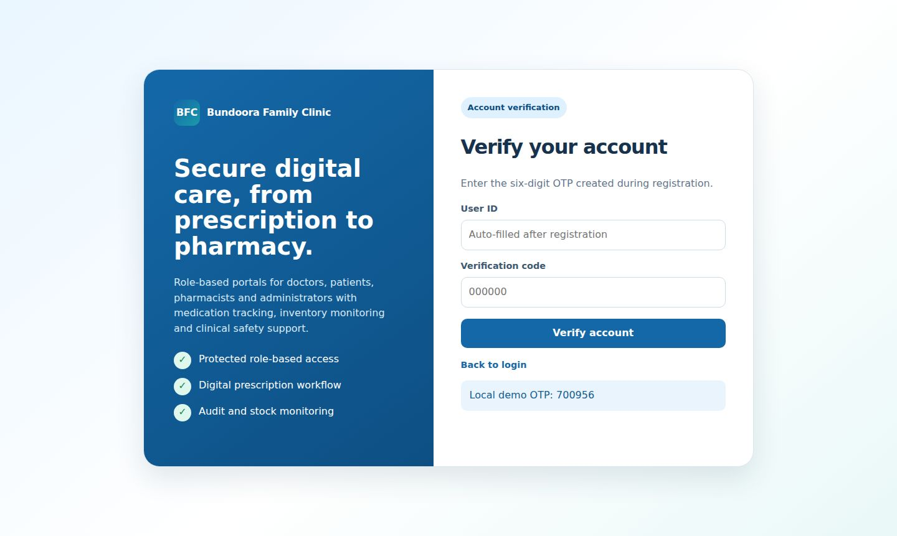 | 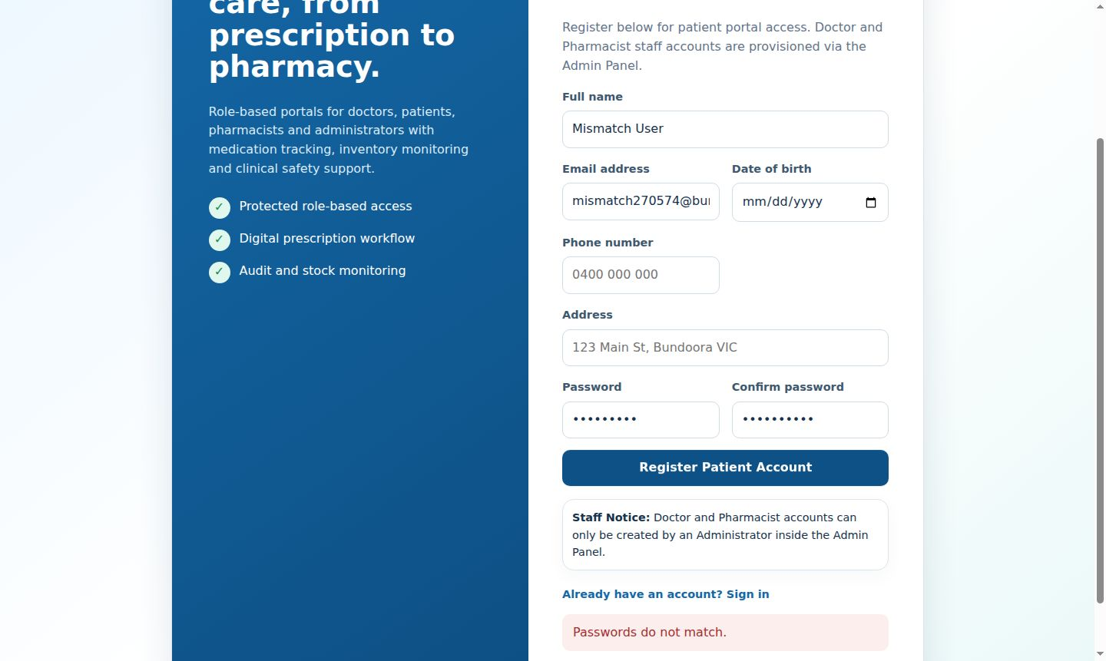
Figure 3.7.1: BFC-SEL-AUTH-01 — Register new patient with valid details (Pass) | Figure 3.7.2: BFC-SEL-AUTH-02 — Registration rejects mismatched passwords (Pass)

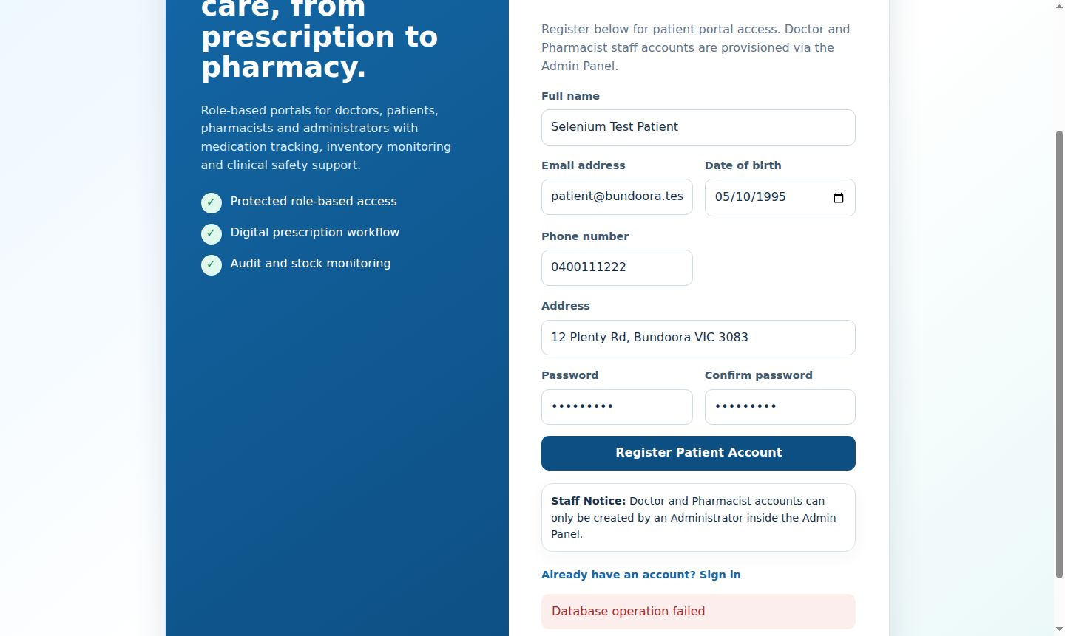 | 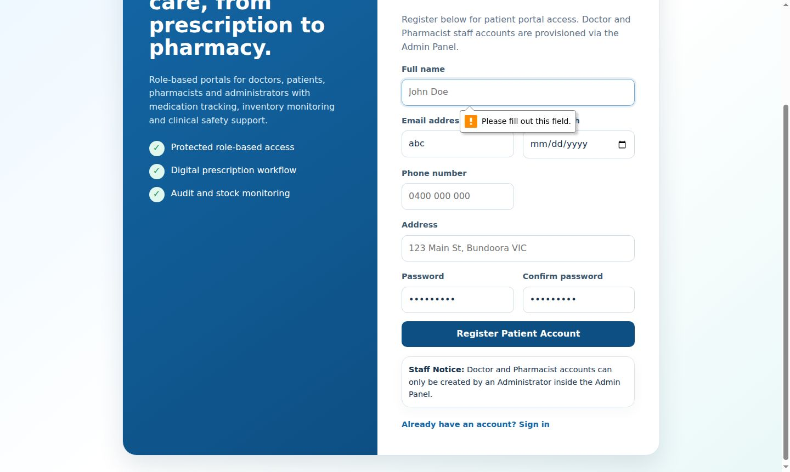
Figure 3.7.3: BFC-SEL-AUTH-03 — Registration rejects duplicate email (Pass) | Figure 3.7.4: BFC-SEL-AUTH-04 — Registration rejects invalid email / blank required fields (Pass)

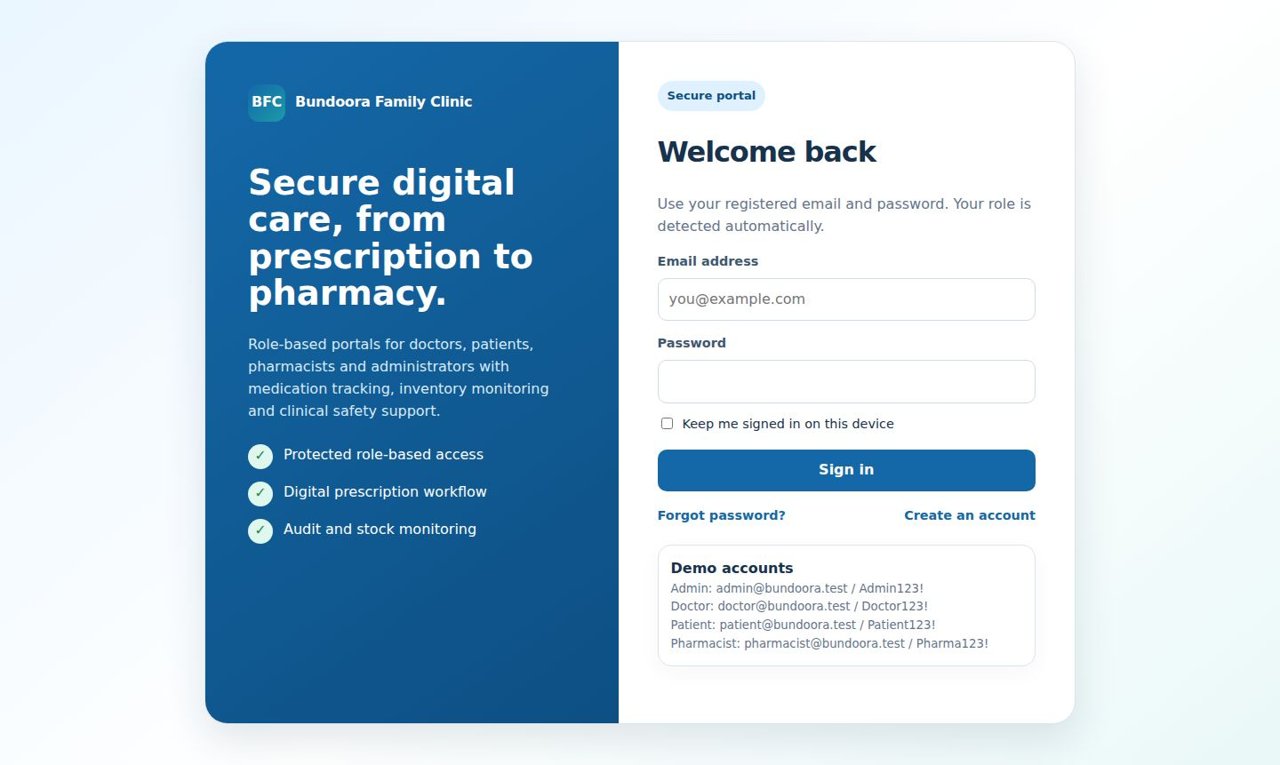 | 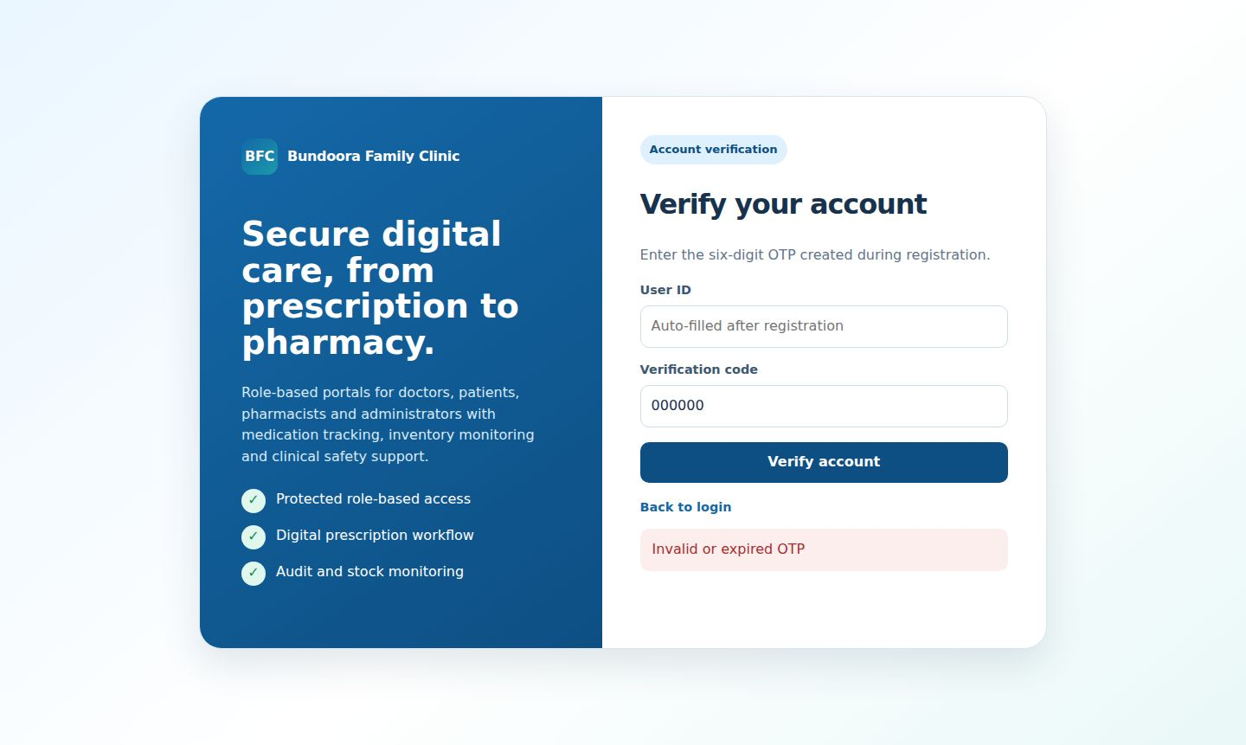
Figure 3.7.5: BFC-SEL-AUTH-05 — OTP verification with correct code (Pass) | Figure 3.7.6: BFC-SEL-AUTH-06 — OTP verification with wrong code (Pass)

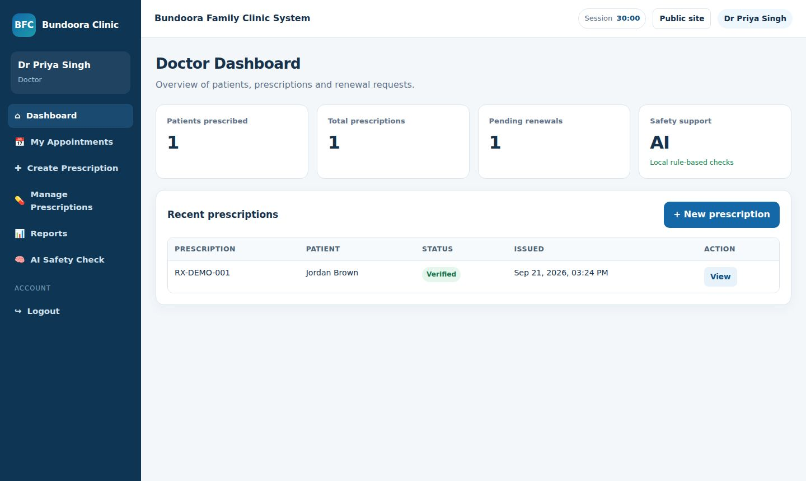 | 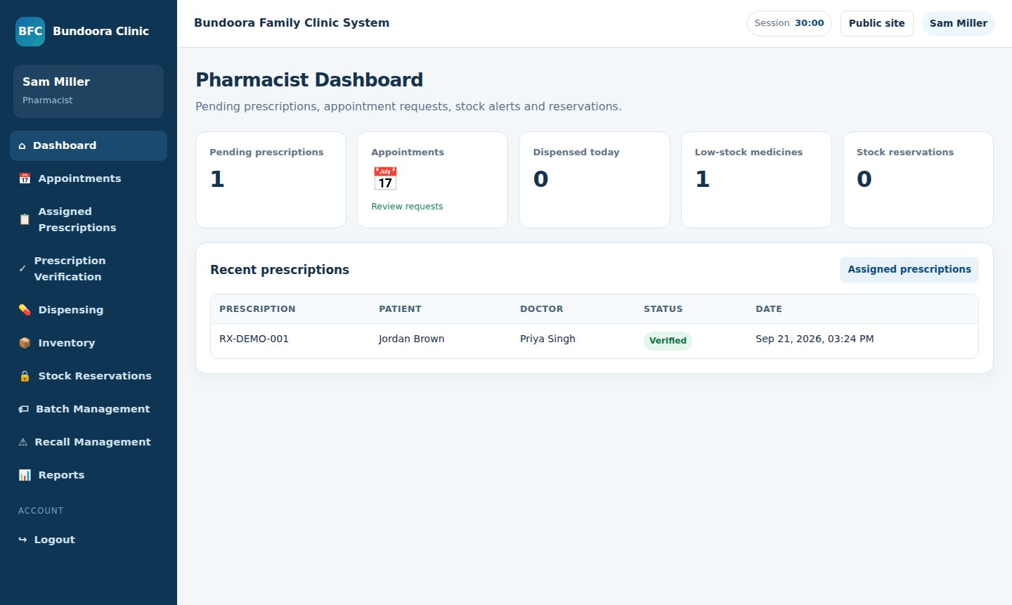
Figure 3.7.7: BFC-SEL-AUTH-07 — Login with valid doctor credentials (Pass) | Figure 3.7.8: BFC-SEL-AUTH-08 — Role-based redirect for each role (Pass)

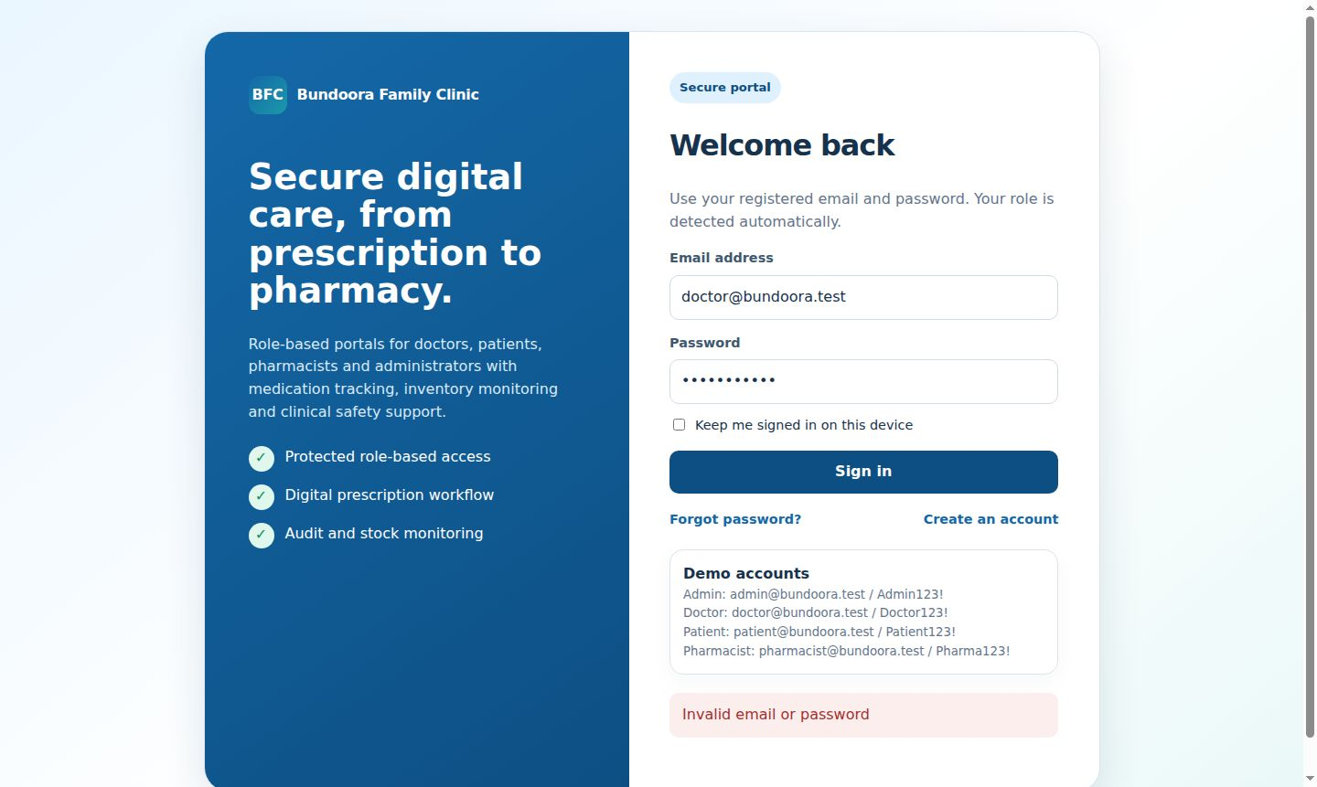 | 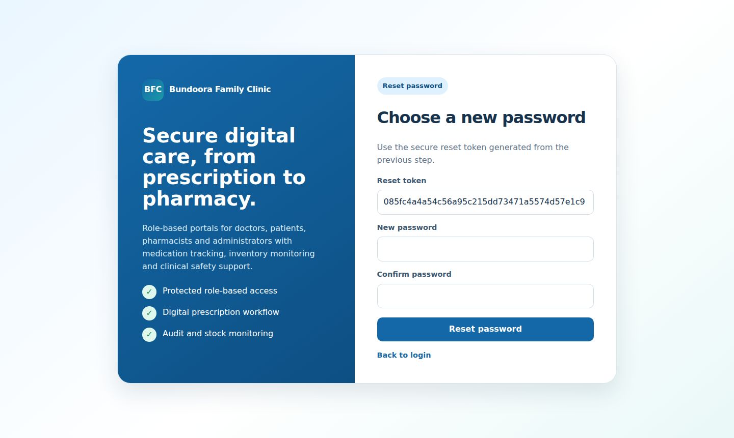
Figure 3.7.9: BFC-SEL-AUTH-09 — Login with wrong password (Pass) | Figure 3.7.10: BFC-SEL-AUTH-10 — Forgot password issues reset token (Pass)

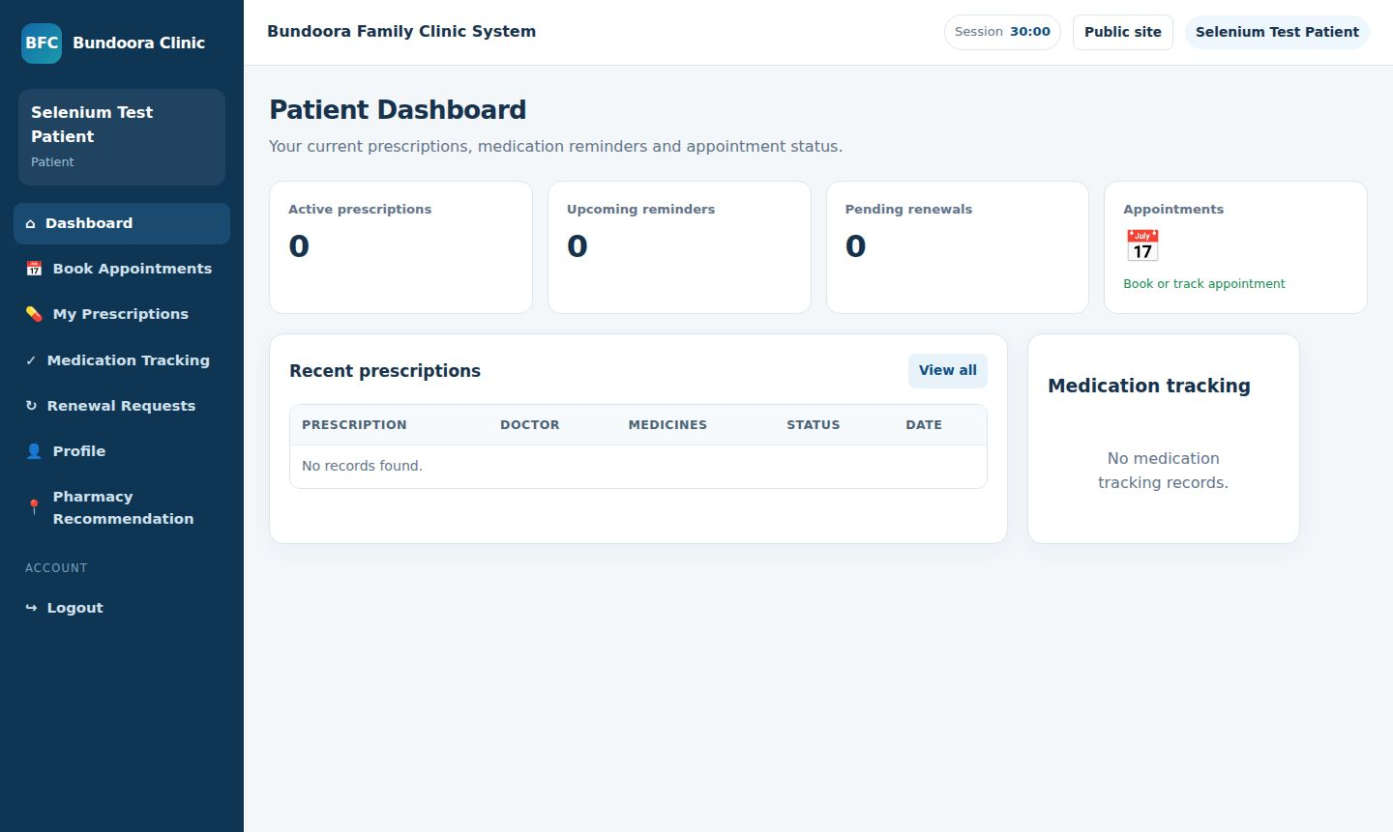 | 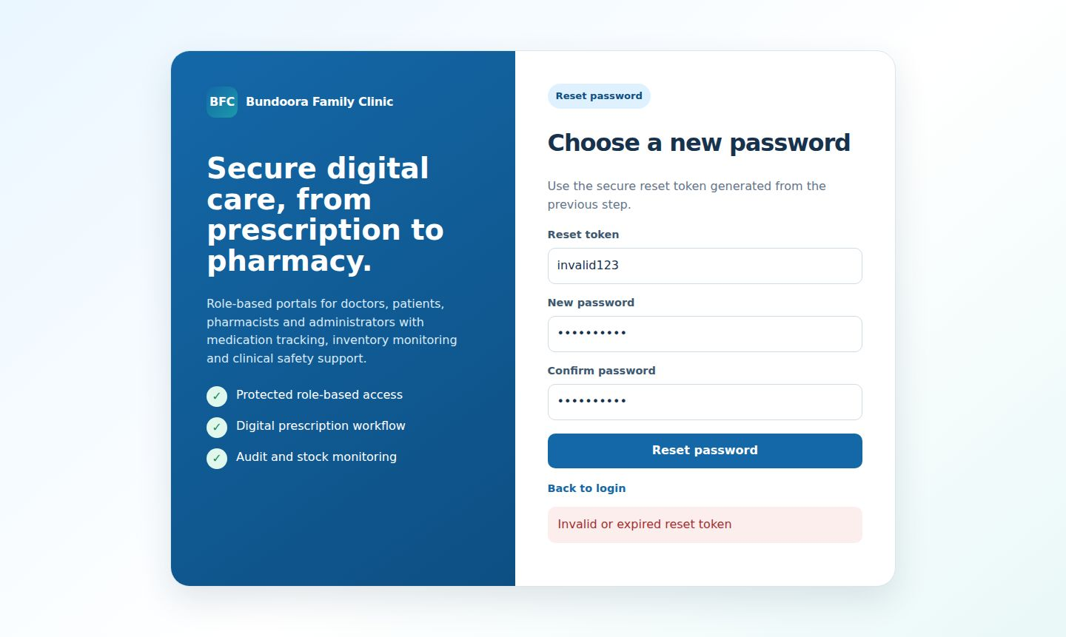
Figure 3.7.11: BFC-SEL-AUTH-11 — Reset password with valid token (Pass) | Figure 3.7.12: BFC-SEL-AUTH-12 — Reset password with invalid token (Pass)

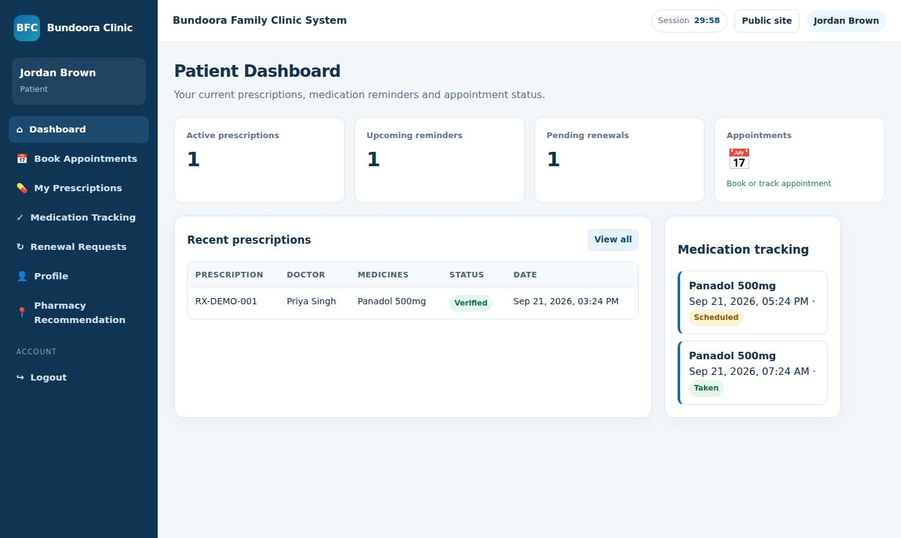
Figure 3.7.13: BFC-SEL-AUTH-13 — Patient cannot open admin pages (Pass) | Figure 3.7.14: BFC-SEL-AUTH-14 — Unauthenticated user cannot open dashboards (Pass)

 | 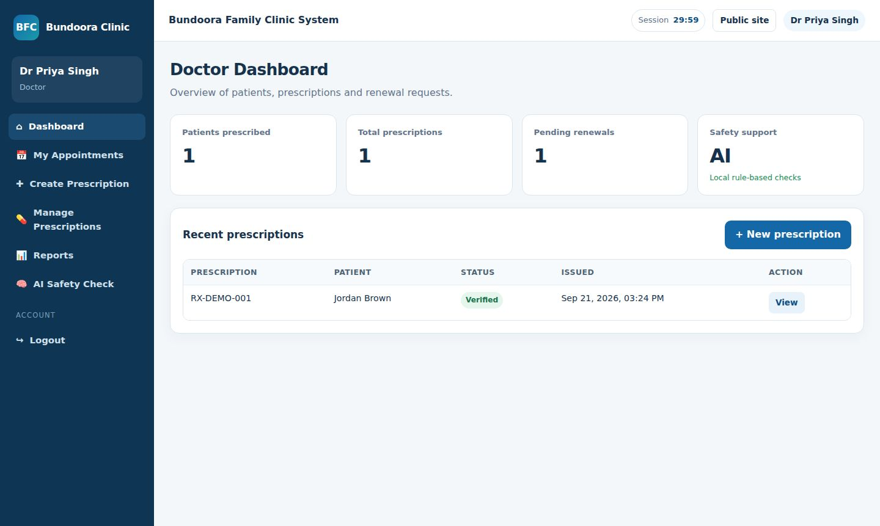
Figure 3.7.15: BFC-SEL-AUTH-15 — Logout ends the session (Pass) | Figure 3.7.16: BFC-SEL-DOC-01 — Doctor dashboard loads summary cards (Pass)

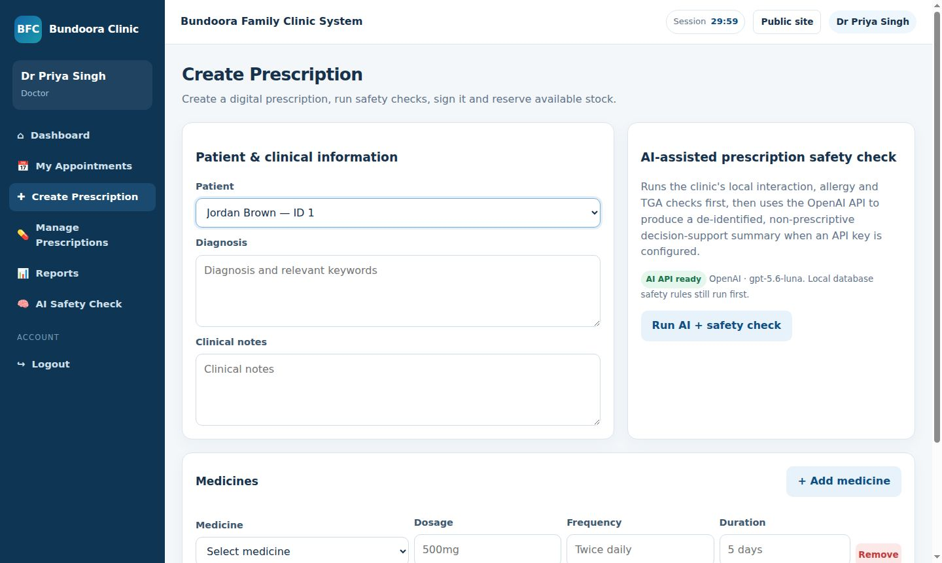 | 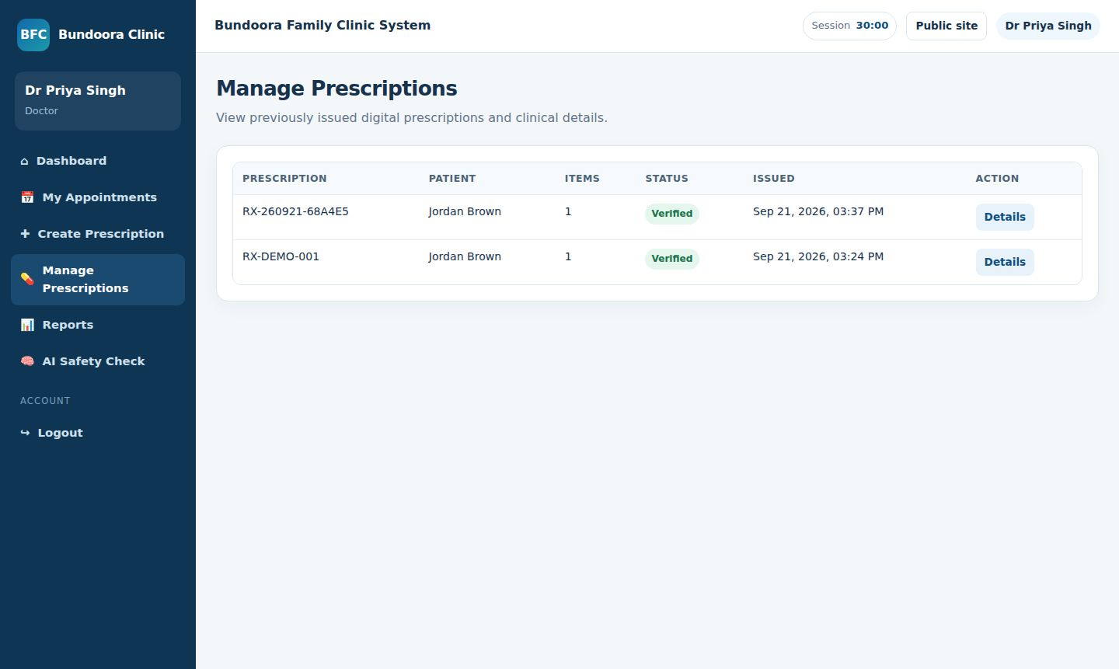
Figure 3.7.17: BFC-SEL-DOC-02 — Select existing patient (Pass) | Figure 3.7.18: BFC-SEL-DOC-03 — Create prescription with one medicine (Pass)

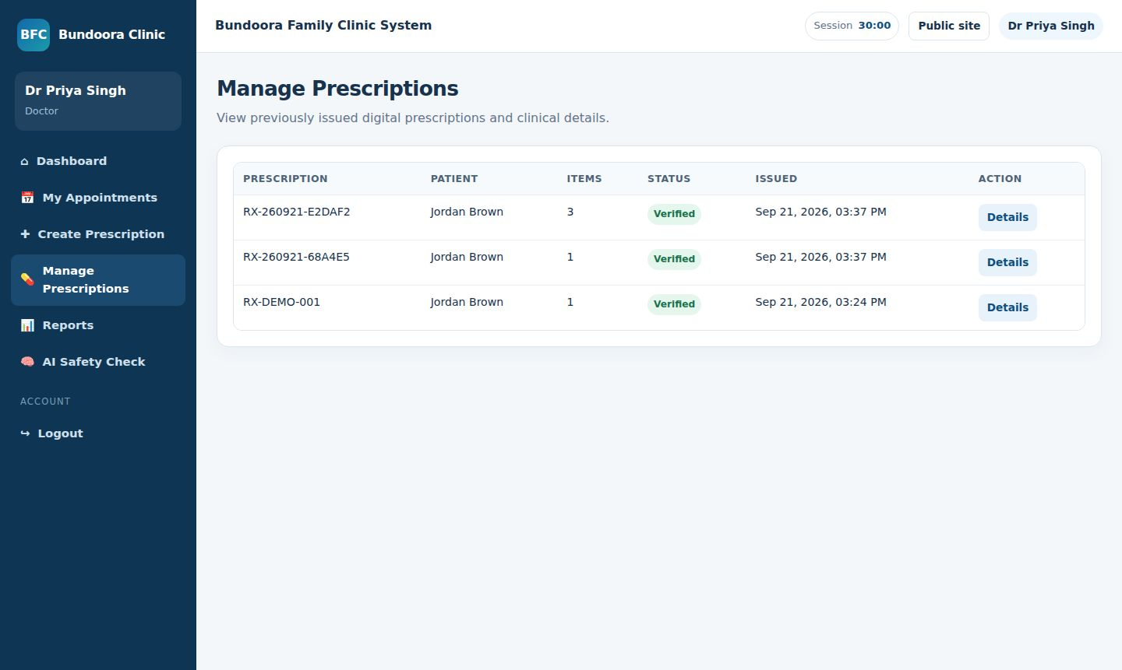 | 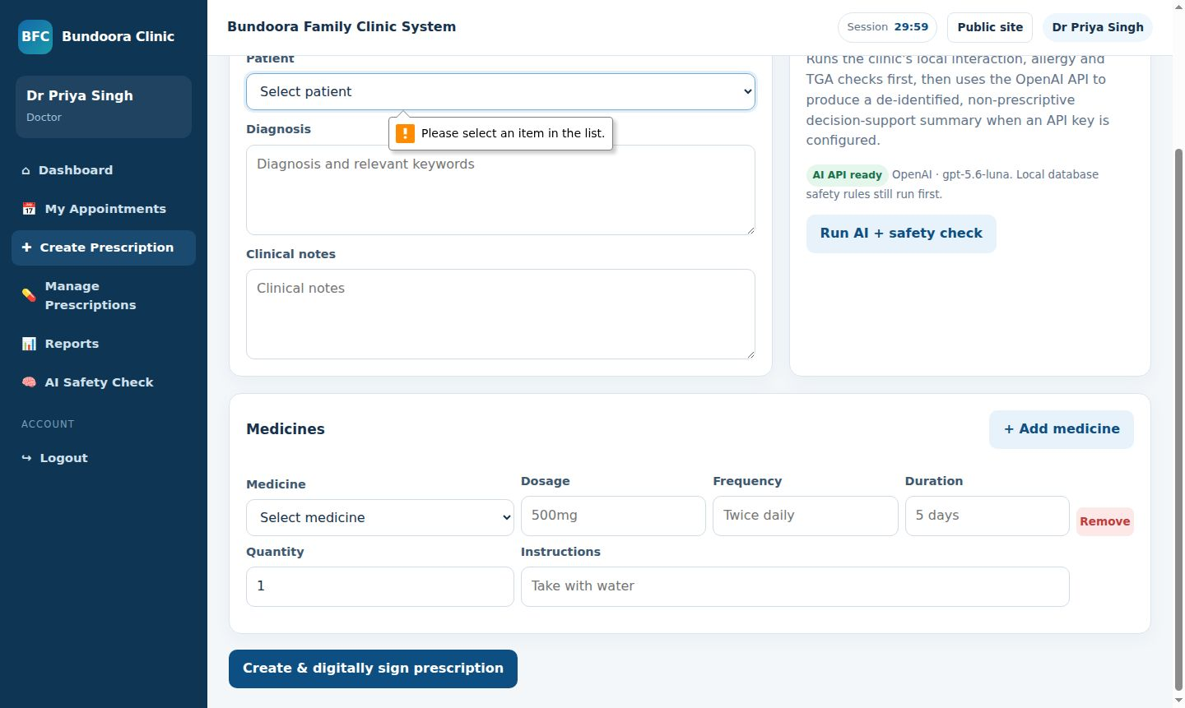
Figure 3.7.19: BFC-SEL-DOC-04 — Add multiple medicine rows (Pass) | Figure 3.7.20: BFC-SEL-DOC-05 — Mandatory field validation (Pass)

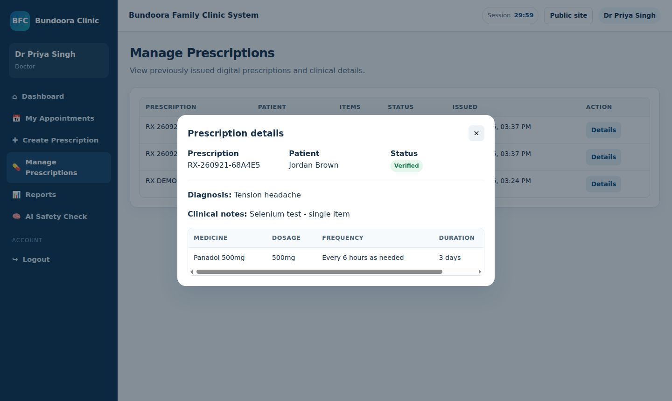 | 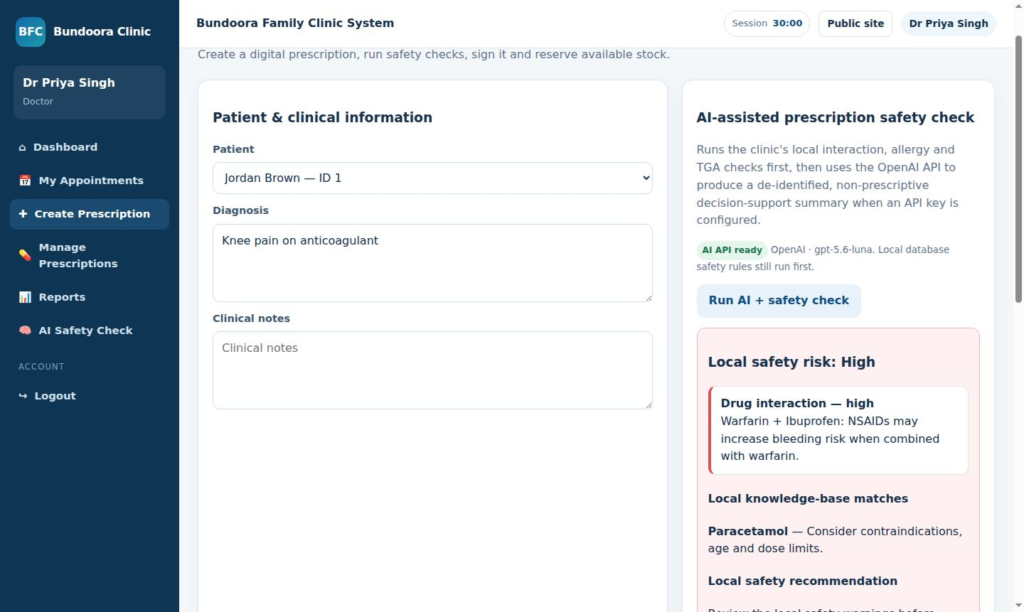
Figure 3.7.21: BFC-SEL-DOC-06 — Diagnosis and clinical notes saved (Pass) | Figure 3.7.22: BFC-SEL-DOC-07 — Safety check — drug interaction (Pass)

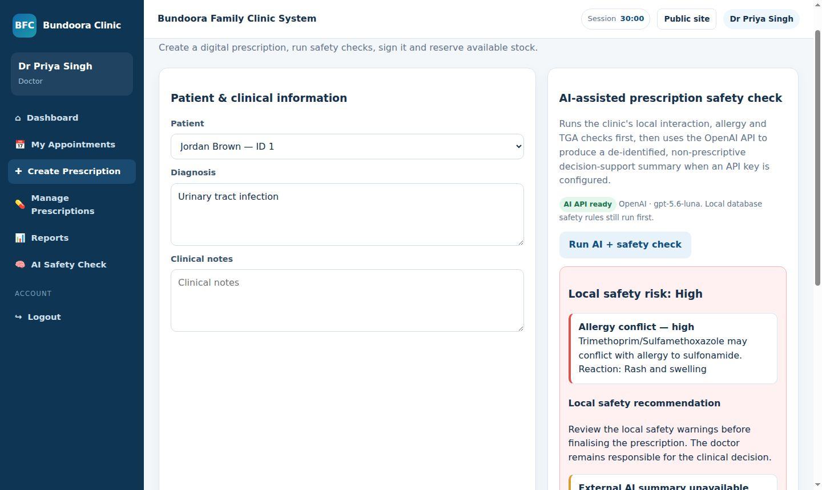
Figure 3.7.23: BFC-SEL-DOC-08 — Safety check — allergy (Pass) | Figure 3.7.24: BFC-SEL-DOC-09 — Digital signature on issue (Pass)

Figure 3.7.25: BFC-SEL-DOC-10 — Edit issued prescription (Fail) | Figure 3.7.26: BFC-SEL-DOC-11 — Cancel prescription (Fail)

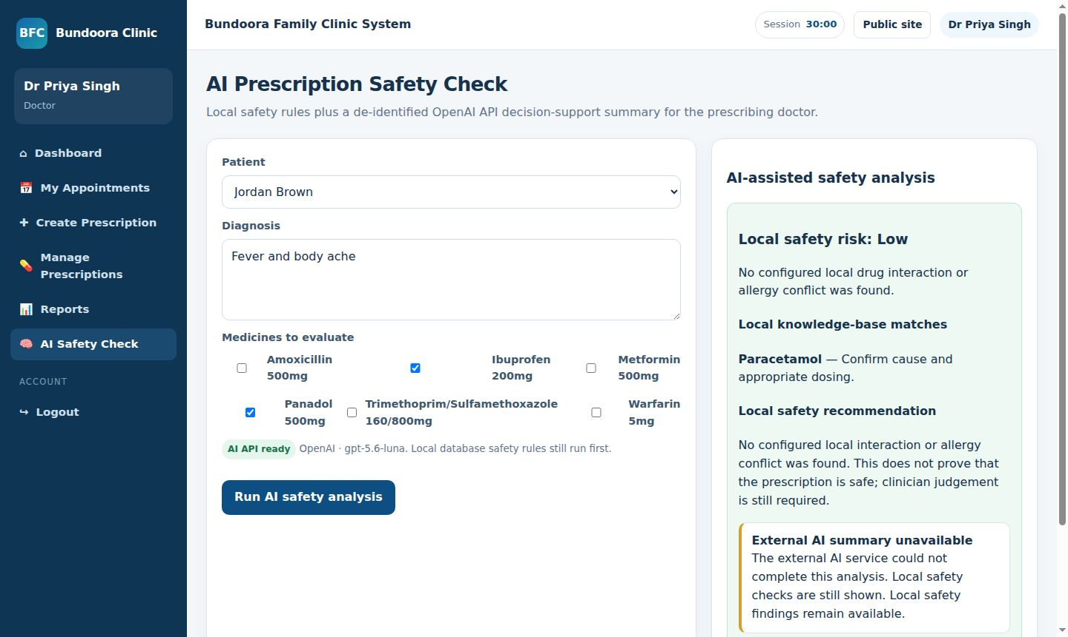 | 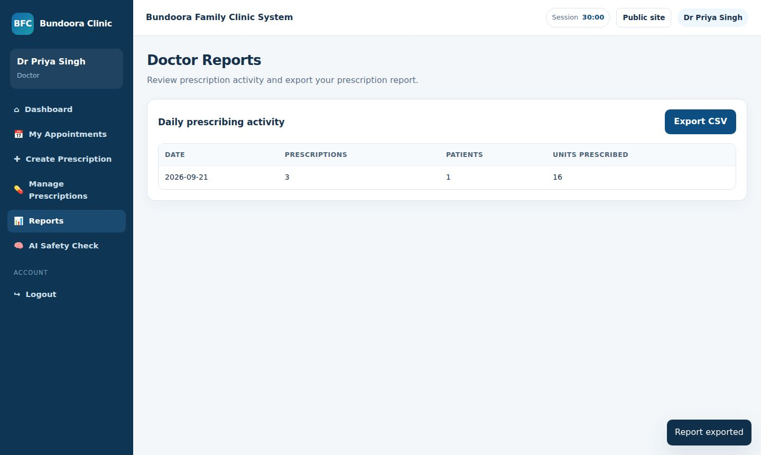
Figure 3.7.27: BFC-SEL-DOC-12 — AI safety check page (Pass) | Figure 3.7.28: BFC-SEL-DOC-13 — Doctor report and CSV export (Pass)

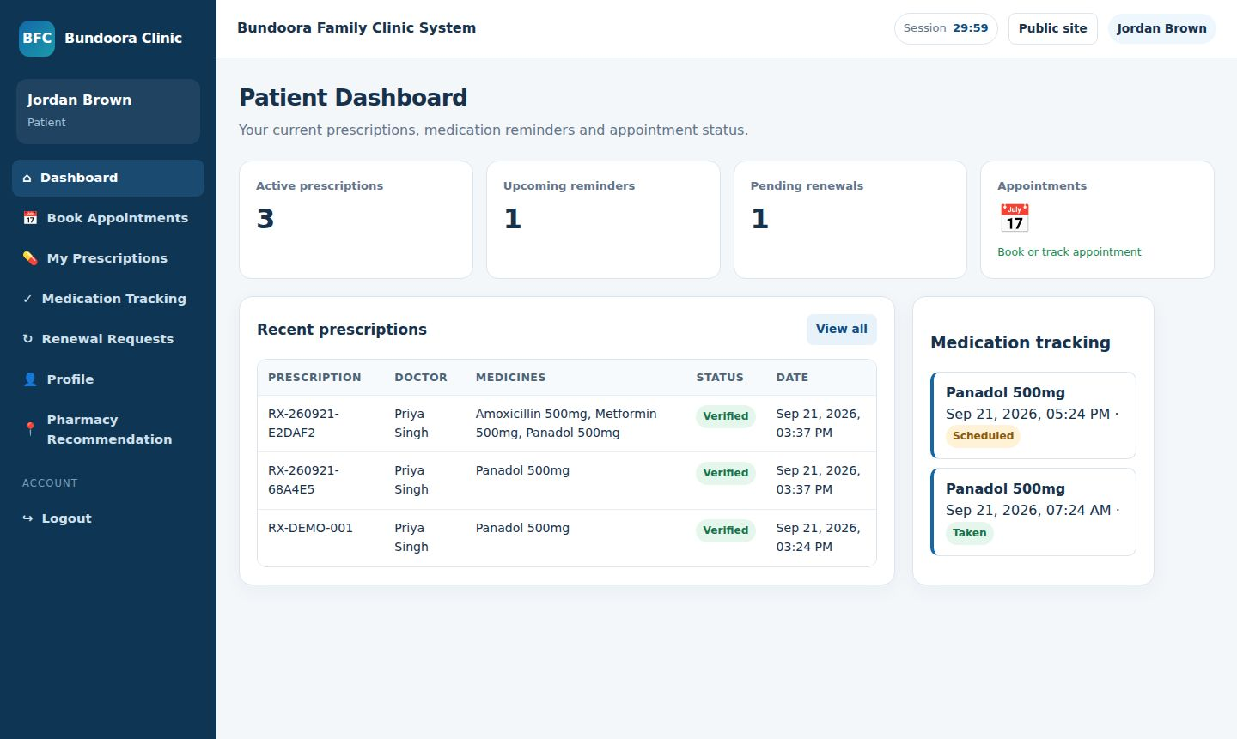 | 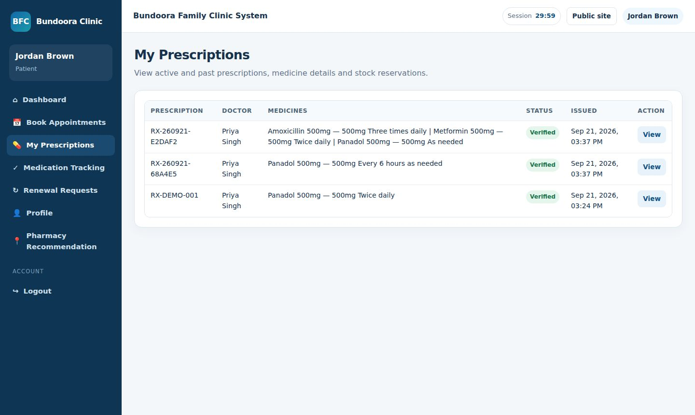
Figure 3.7.29: BFC-SEL-PAT-01 — Patient dashboard loads (Pass) | Figure 3.7.30: BFC-SEL-PAT-02 — View own prescriptions only (Pass)

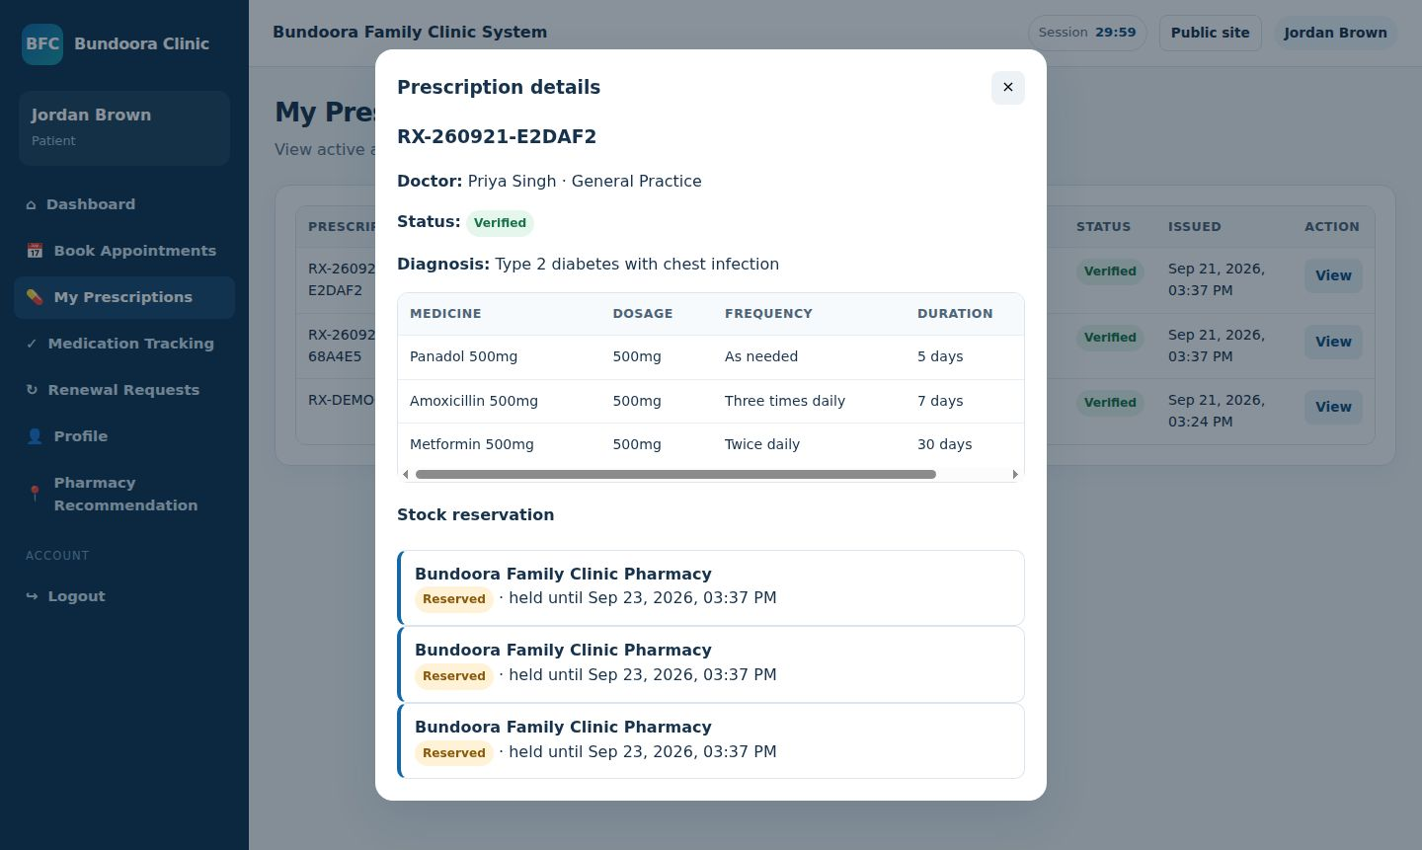 | 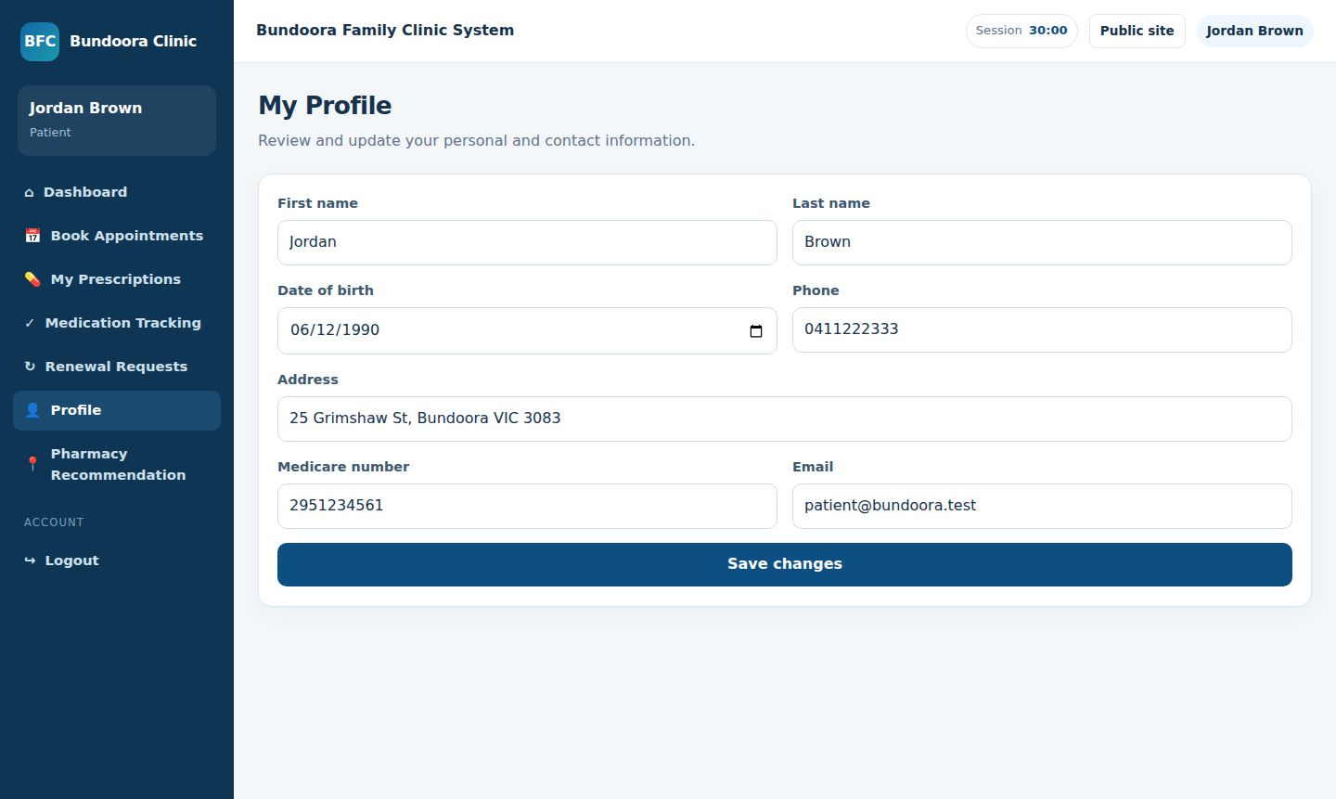
Figure 3.7.31: BFC-SEL-PAT-03 — View prescription detail (Pass) | Figure 3.7.32: BFC-SEL-PAT-04 — Update profile (Pass)

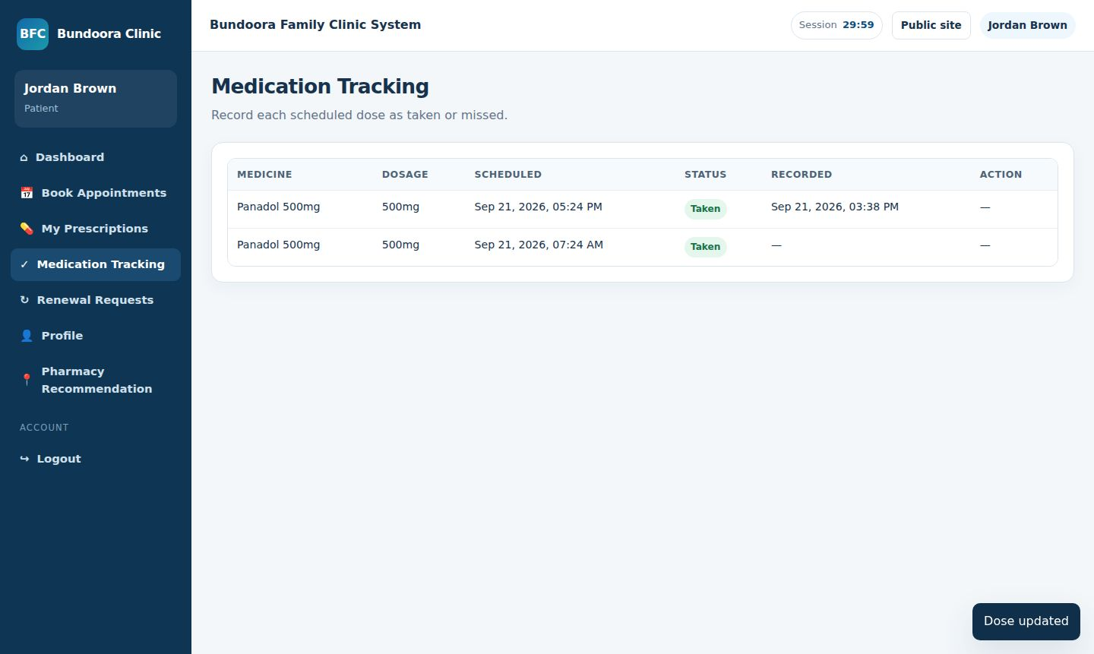 | 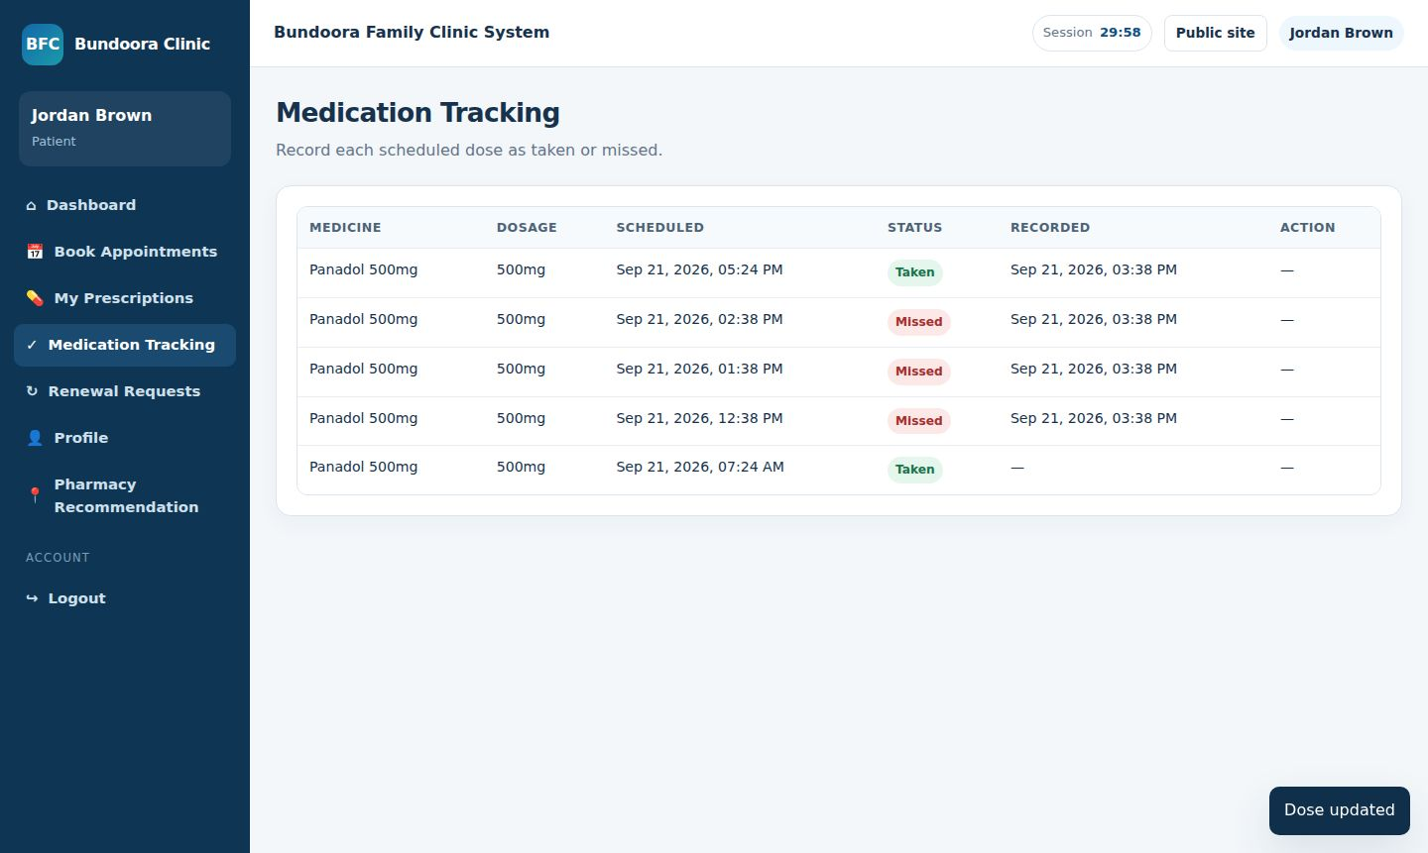
Figure 3.7.33: BFC-SEL-PAT-05 — Mark dose as Taken (Pass) | Figure 3.7.34: BFC-SEL-PAT-06 — Missed doses create alert (Pass)

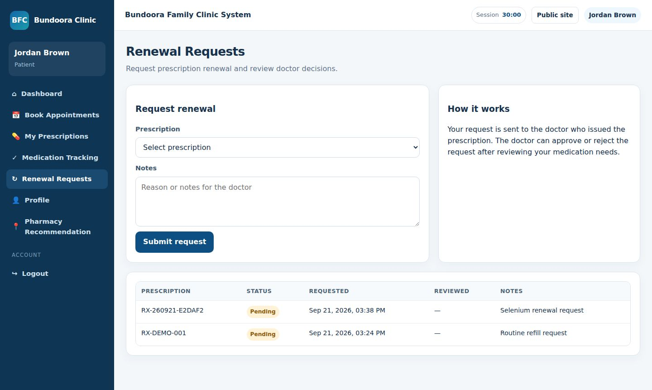 | 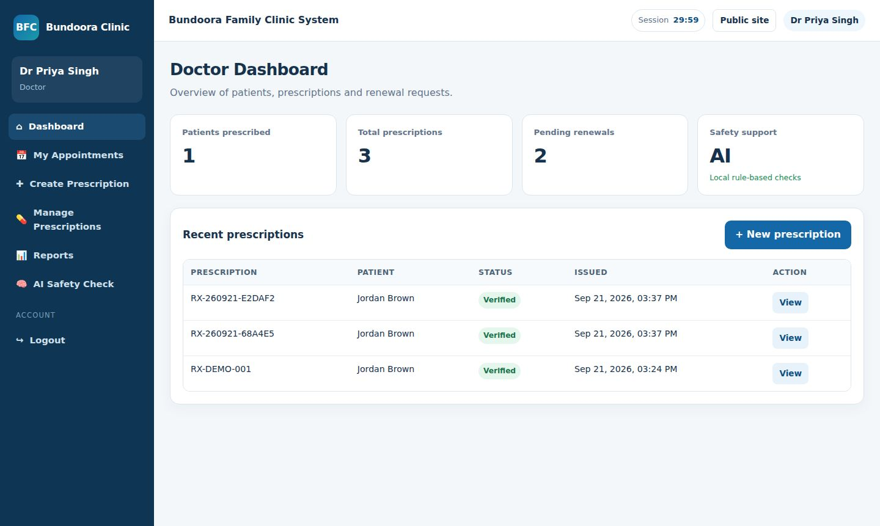
Figure 3.7.35: BFC-SEL-PAT-07 — Submit renewal request (Fail) | Figure 3.7.36: BFC-SEL-PAT-08 — Renewal visible to doctor (Pass)

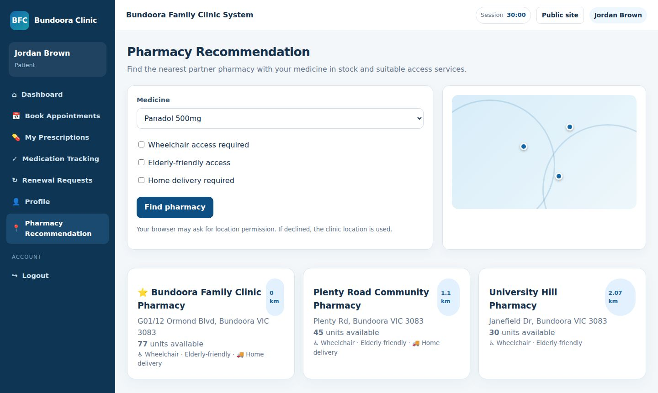 | 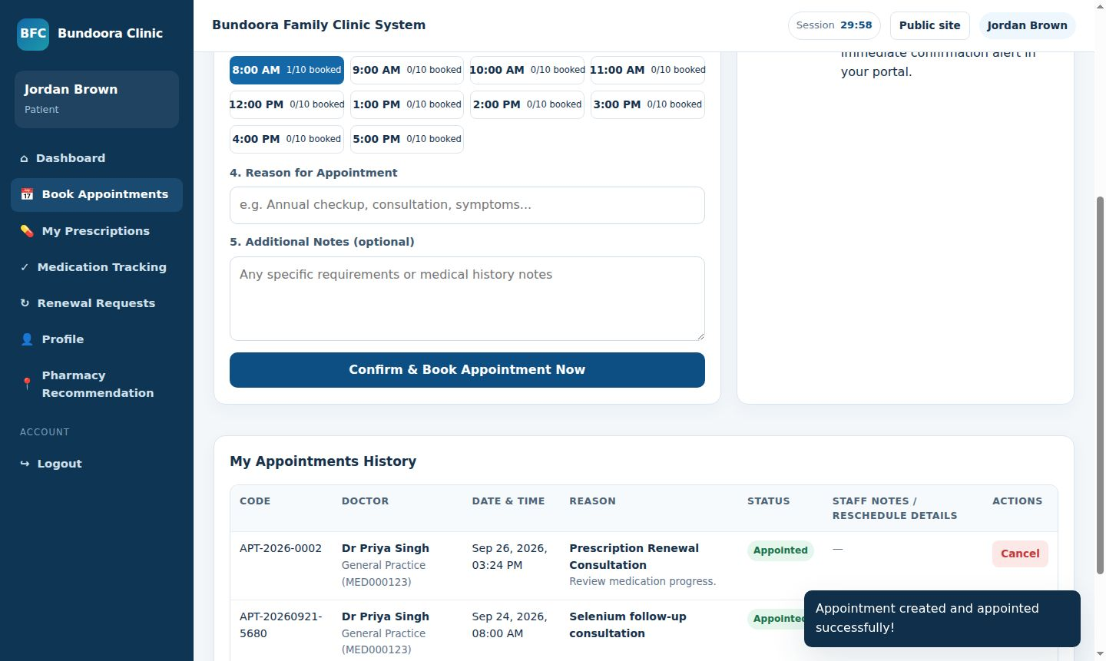
Figure 3.7.37: BFC-SEL-PAT-09 — Pharmacy recommendation (Pass) | Figure 3.7.38: BFC-SEL-PAT-10 — Book appointment (Pass)

 | 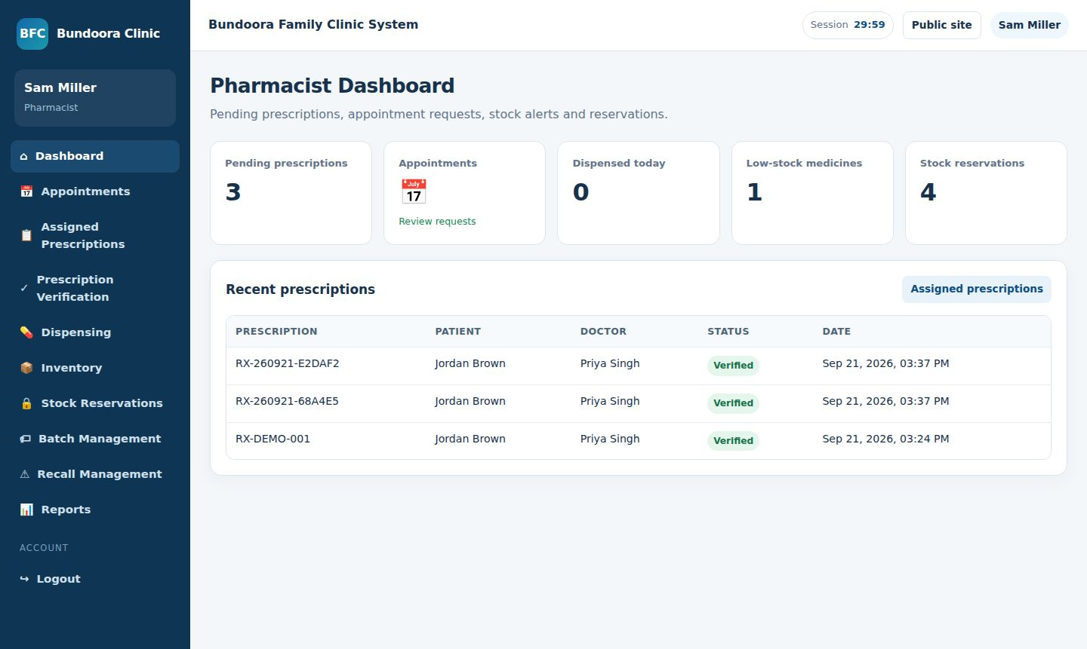
Figure 3.7.39: BFC-SEL-PAT-11 — Patient cannot change issued prescription (Pass) | Figure 3.7.40: BFC-SEL-PHM-01 — Pharmacist dashboard loads (Pass)

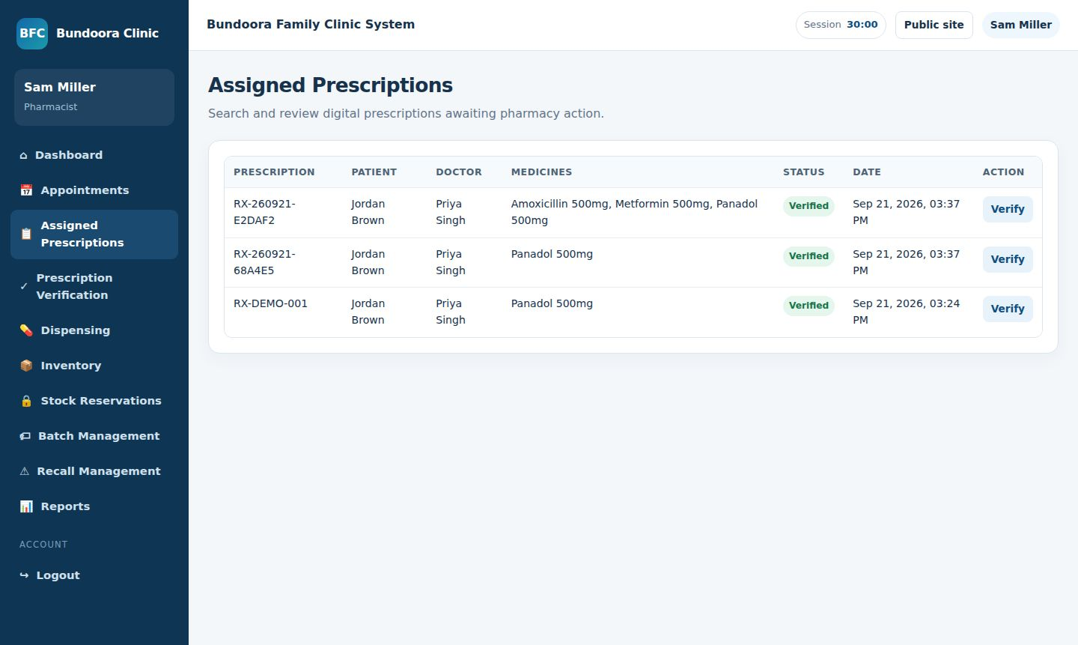 | 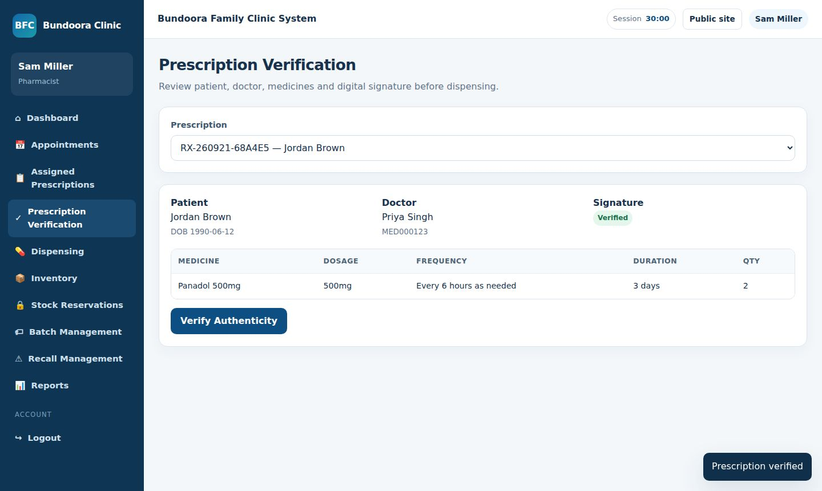
Figure 3.7.41: BFC-SEL-PHM-02 — View assigned prescriptions (Pass) | Figure 3.7.42: BFC-SEL-PHM-03 — Verify prescription signature (Pass)

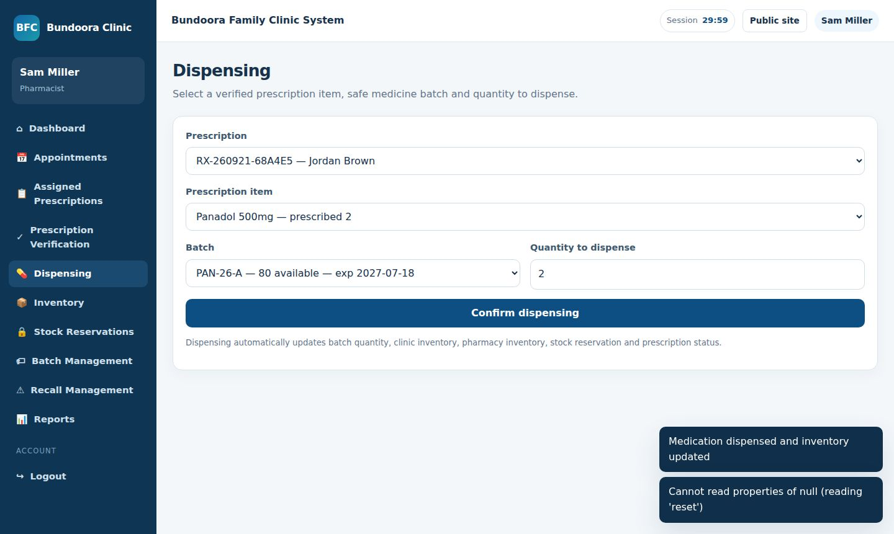 | 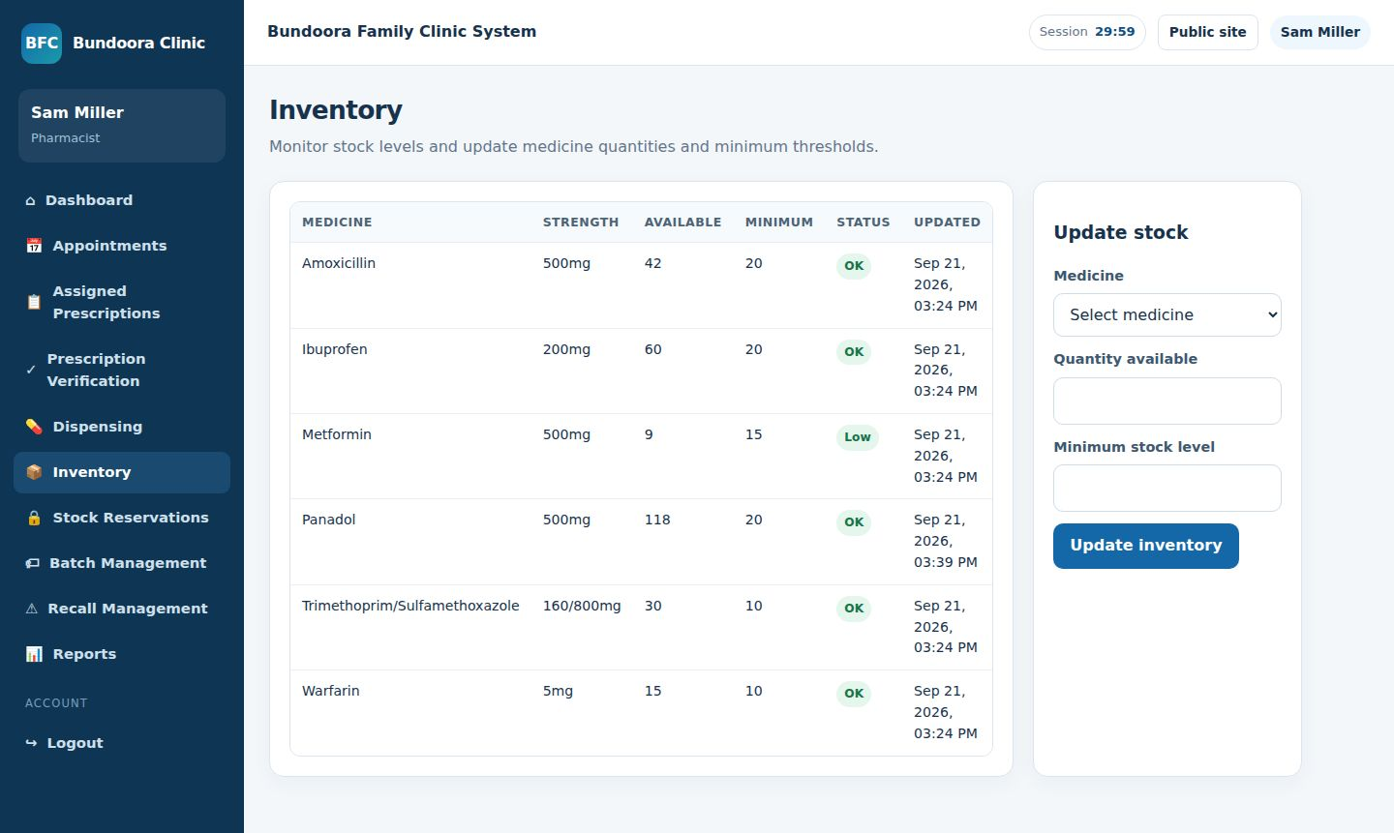
Figure 3.7.43: BFC-SEL-PHM-04 — Dispense medicine with batch (Pass) | Figure 3.7.44: BFC-SEL-PHM-05 — Automatic stock reduction (Pass)

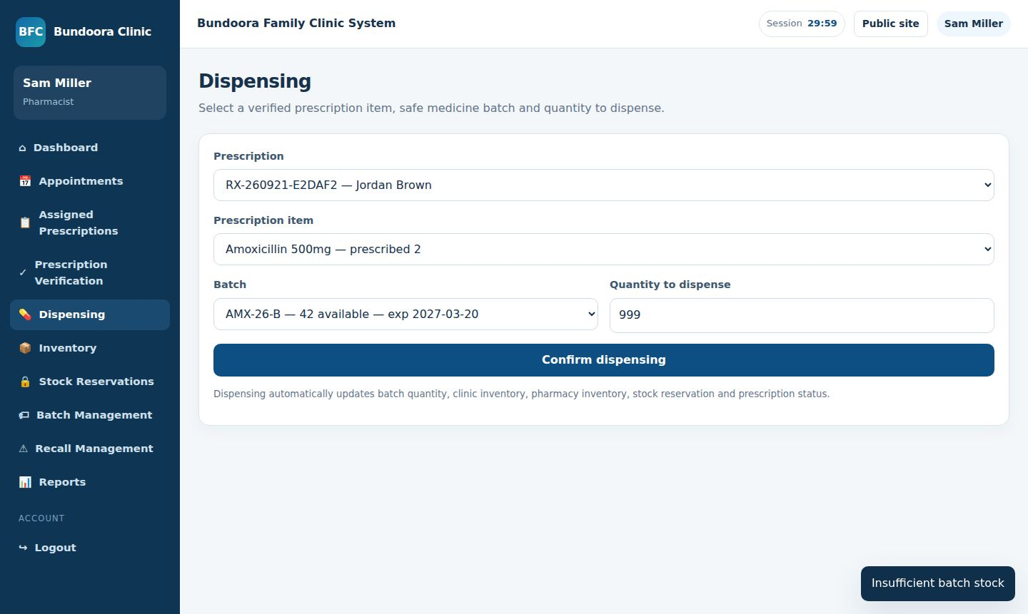 | 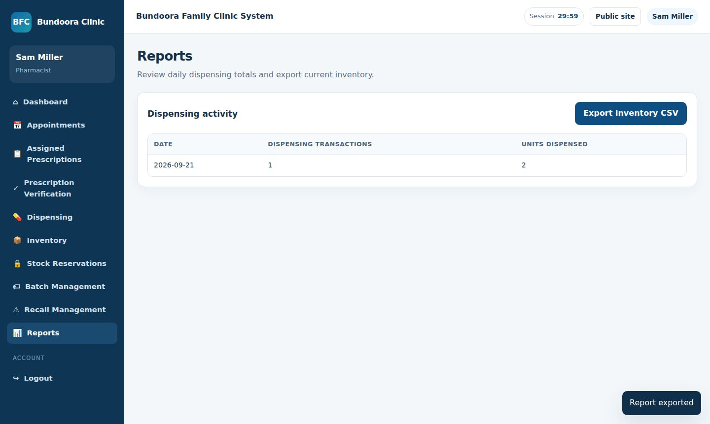
Figure 3.7.45: BFC-SEL-PHM-06 — Block dispensing above stock (Pass) | Figure 3.7.46: BFC-SEL-PHM-07 — Daily dispensing report and export (Pass)

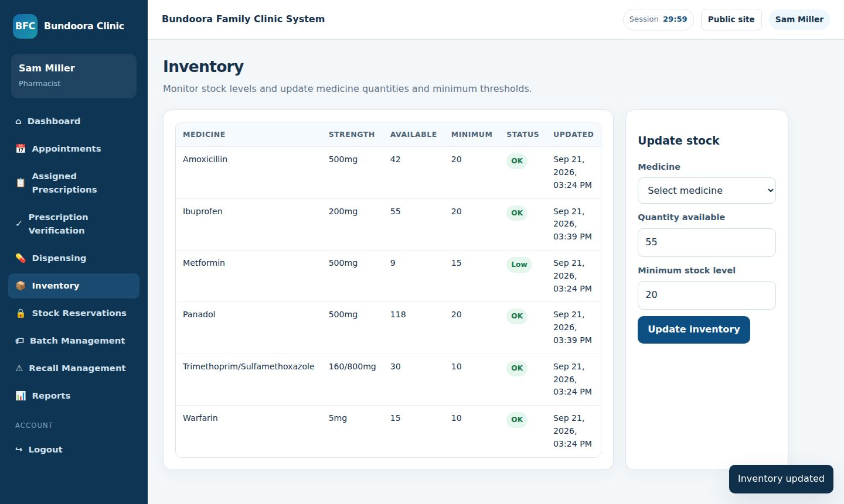 | 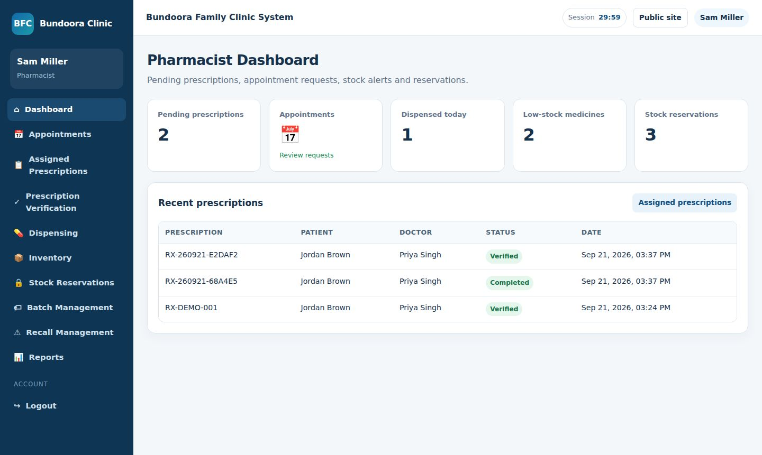
Figure 3.7.47: BFC-SEL-PHM-08 — Update inventory (Pass) | Figure 3.7.48: BFC-SEL-PHM-09 — Low-stock indicator (Pass)

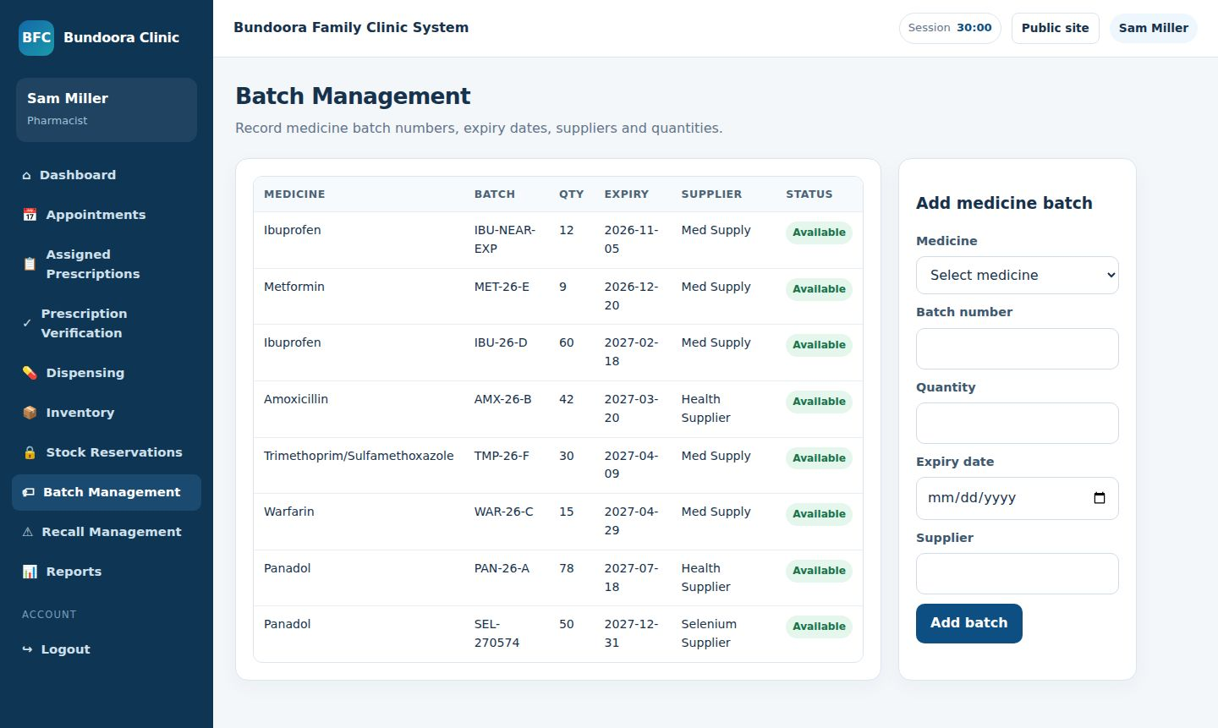 | 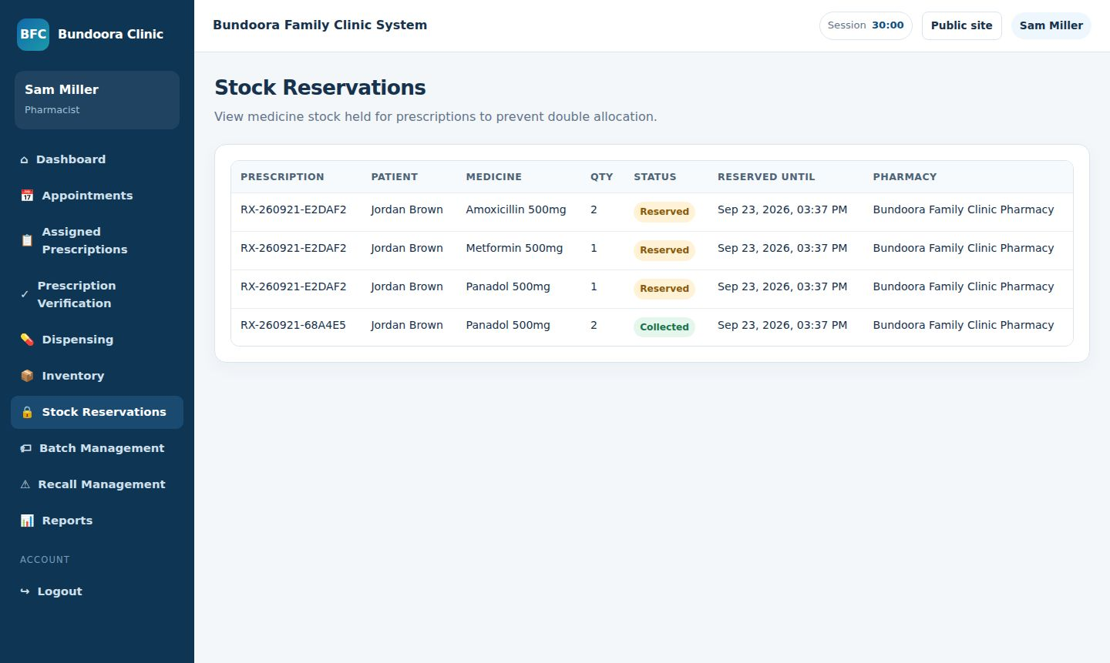
Figure 3.7.49: BFC-SEL-PHM-10 — Add medicine batch with expiry (Fail) | Figure 3.7.50: BFC-SEL-PHM-11 — Stock reservations list (Pass)

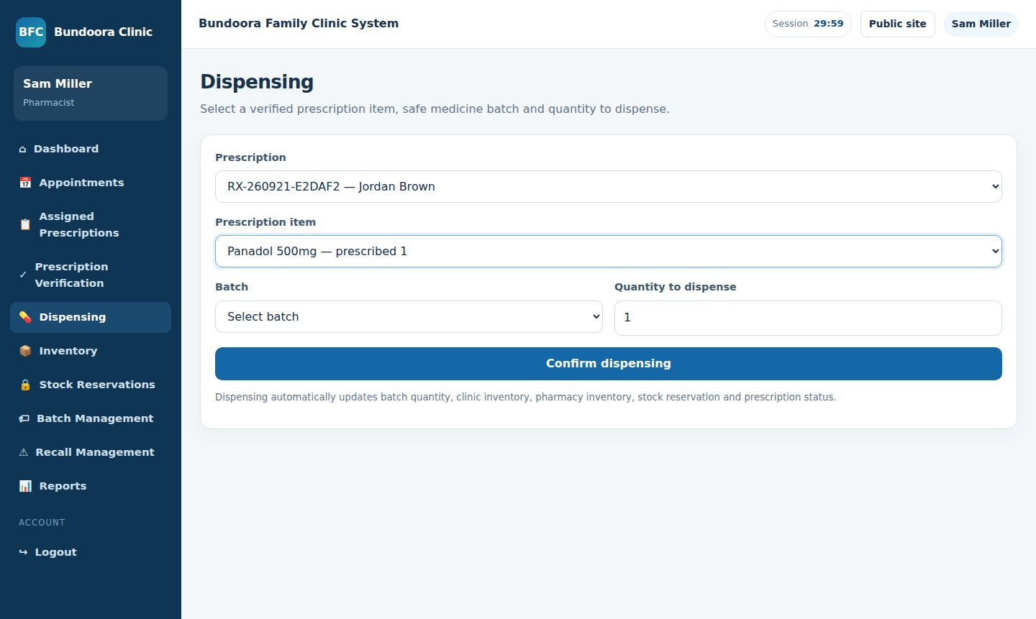 | 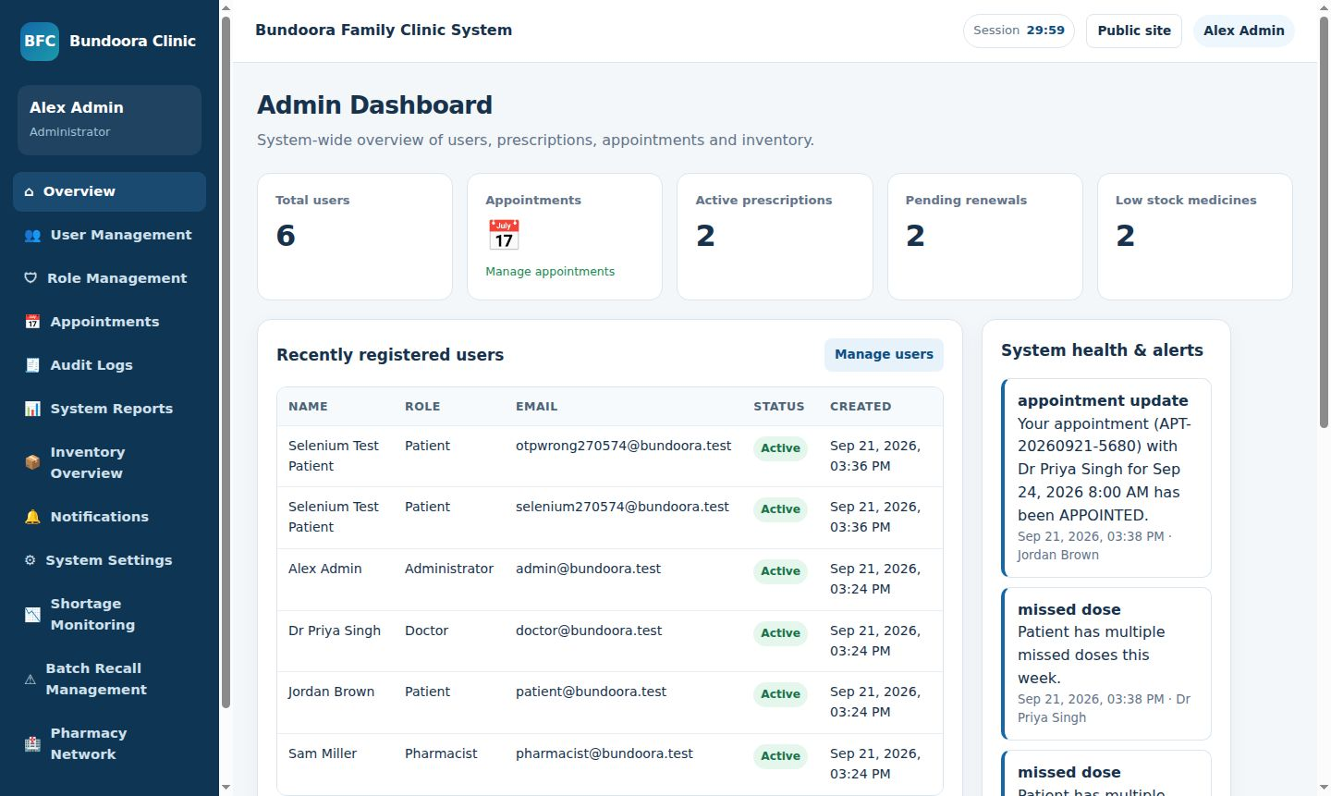
Figure 3.7.51: BFC-SEL-PHM-12 — Recalled batch blocked from dispensing (Pass) | Figure 3.7.52: BFC-SEL-ADM-01 — Admin dashboard loads (Pass)

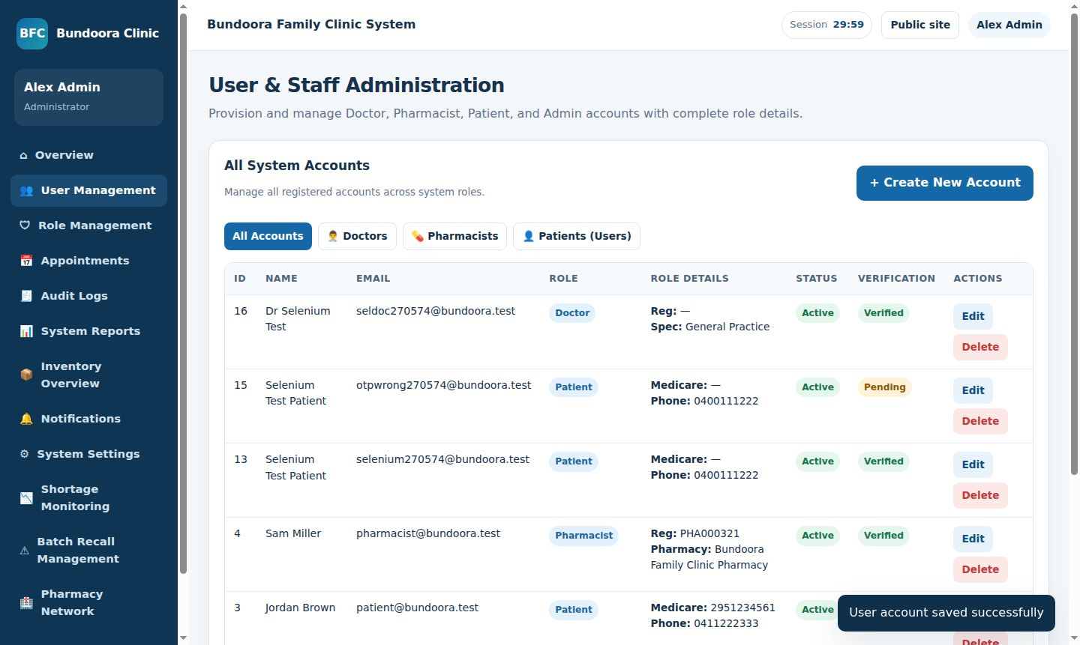 | 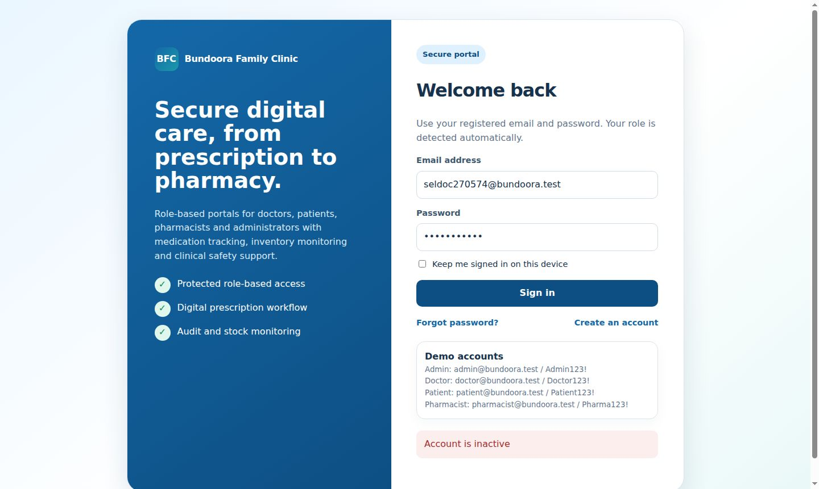
Figure 3.7.53: BFC-SEL-ADM-02 — Create user from admin panel (Pass) | Figure 3.7.54: BFC-SEL-ADM-03 — Deactivate user (Pass)

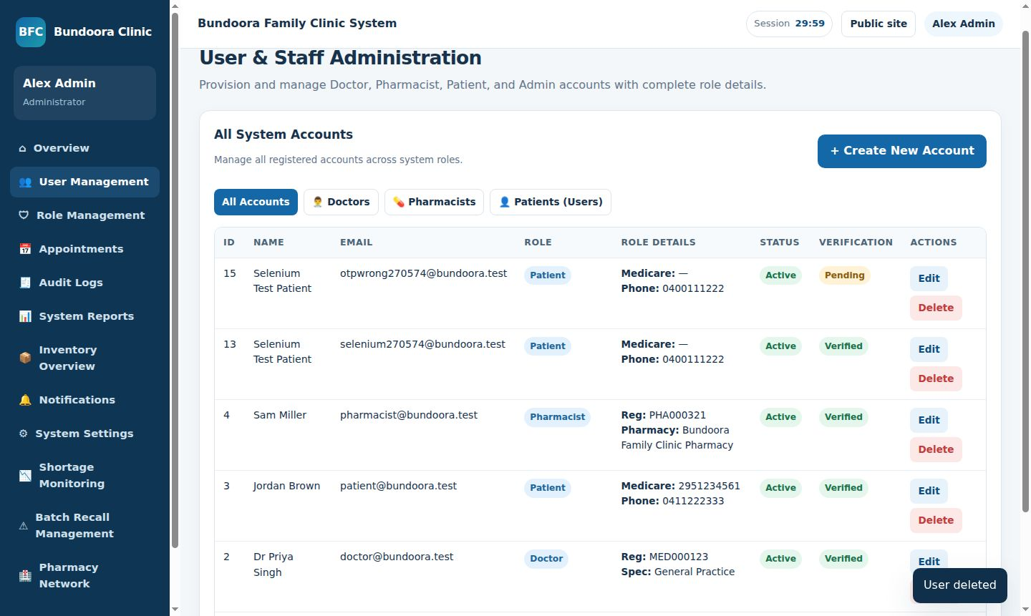 | 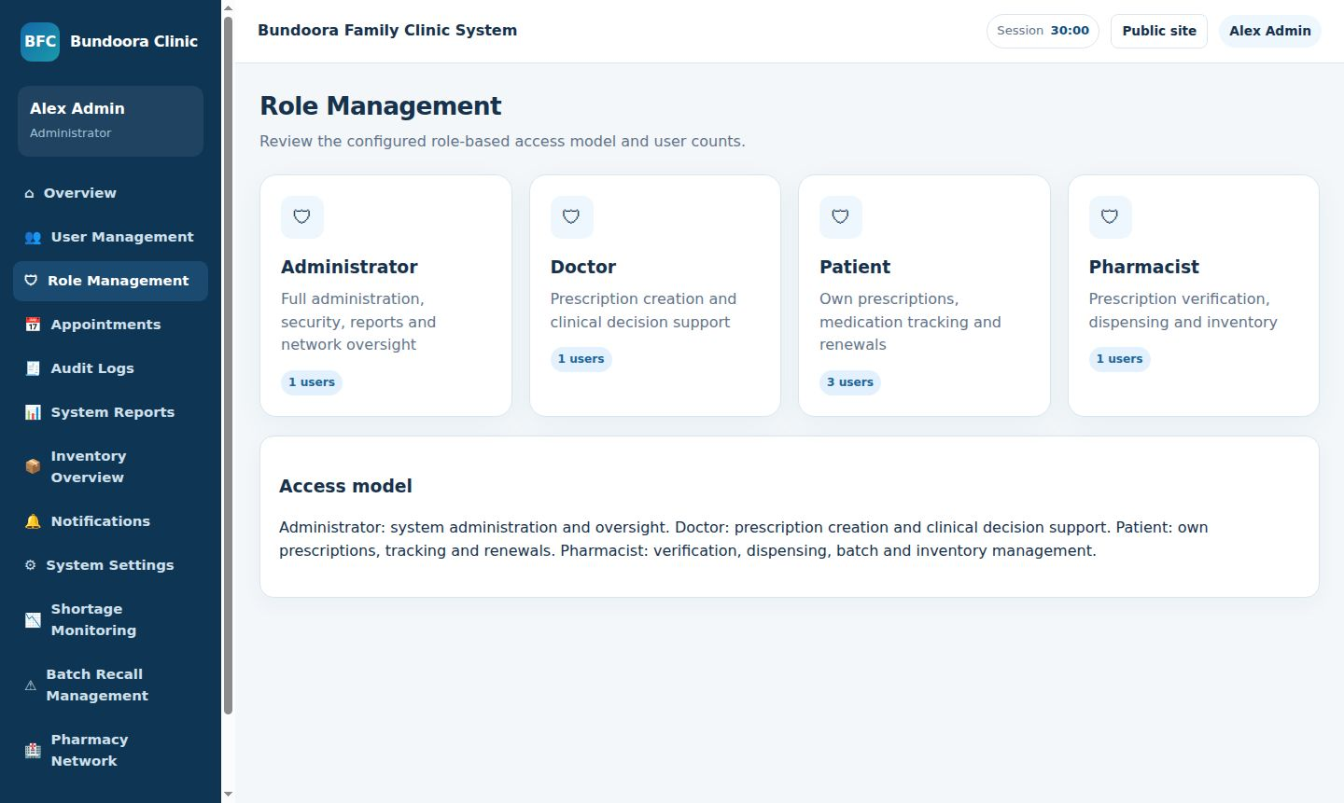
Figure 3.7.55: BFC-SEL-ADM-04 — Delete user (Pass) | Figure 3.7.56: BFC-SEL-ADM-05 — Roles page (Pass)

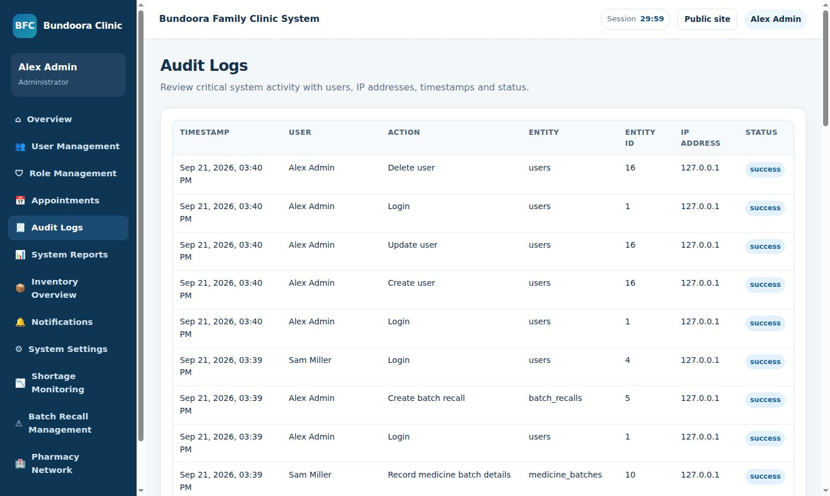 | 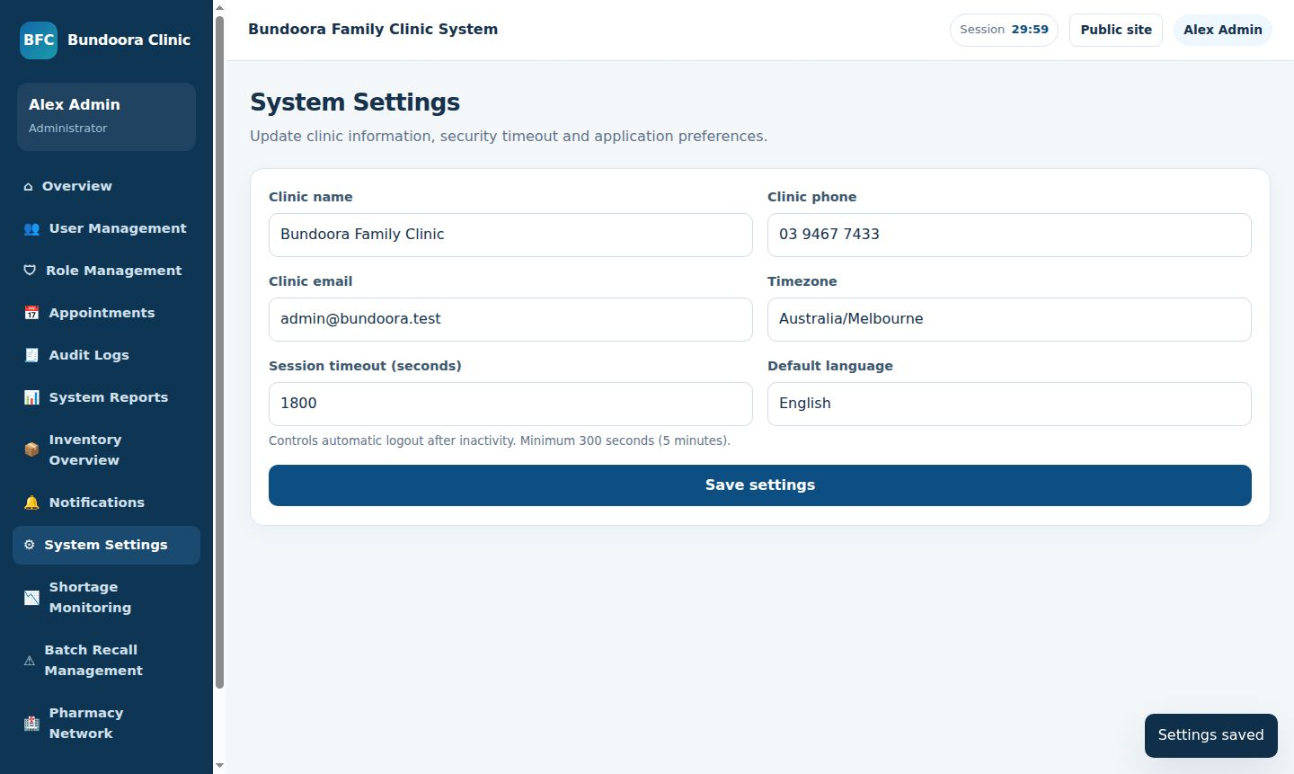
Figure 3.7.57: BFC-SEL-ADM-06 — Audit log records actions (Pass) | Figure 3.7.58: BFC-SEL-ADM-07 — Session timeout setting (Pass)

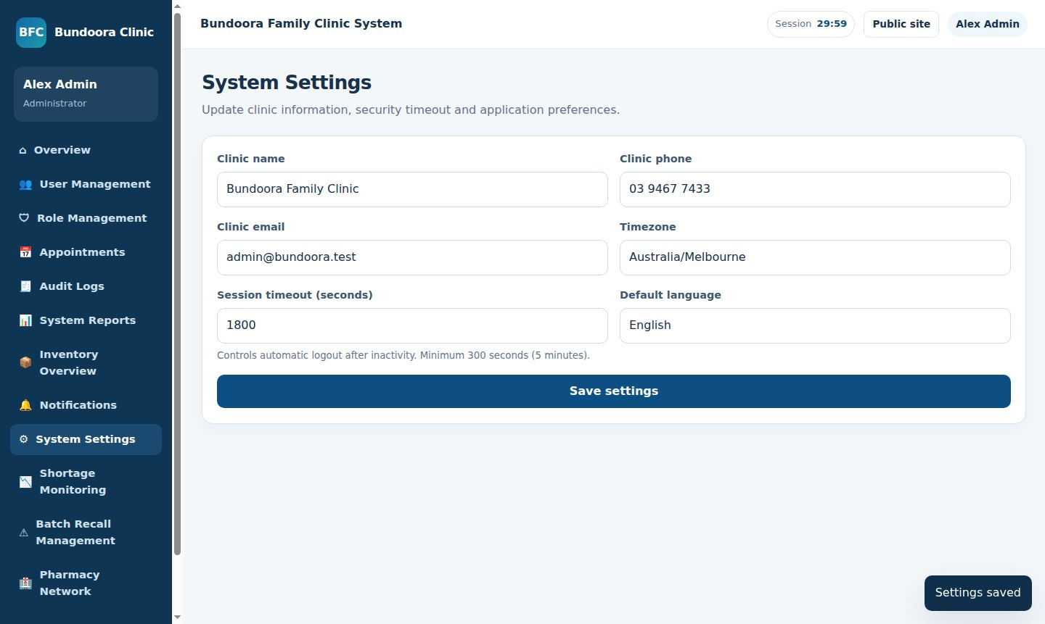 | 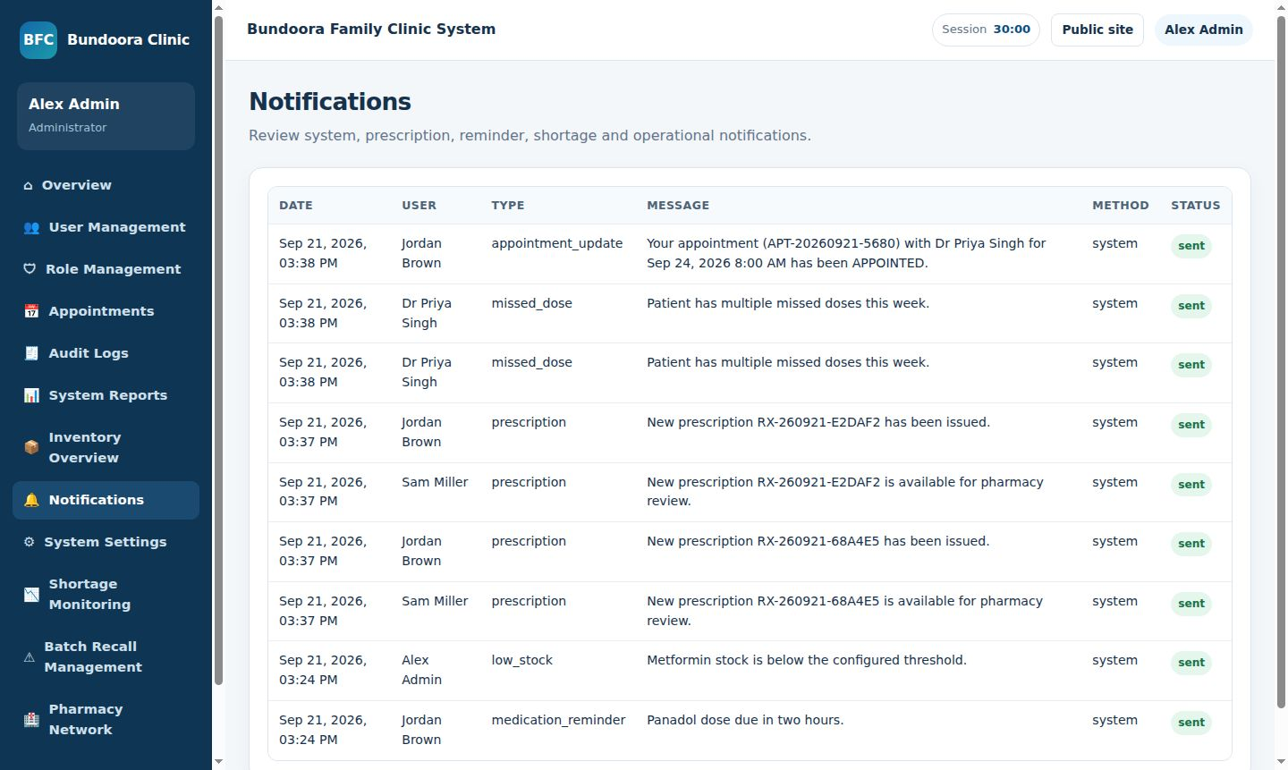
Figure 3.7.59: BFC-SEL-ADM-08 — System settings saved (Pass) | Figure 3.7.60: BFC-SEL-ADM-09 — Notifications log (Pass)

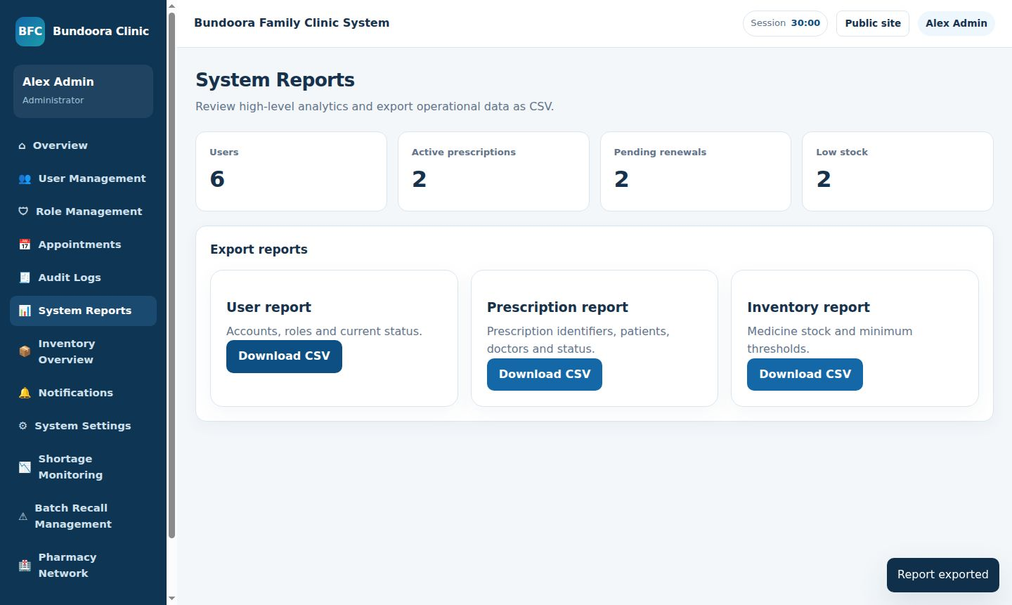 | 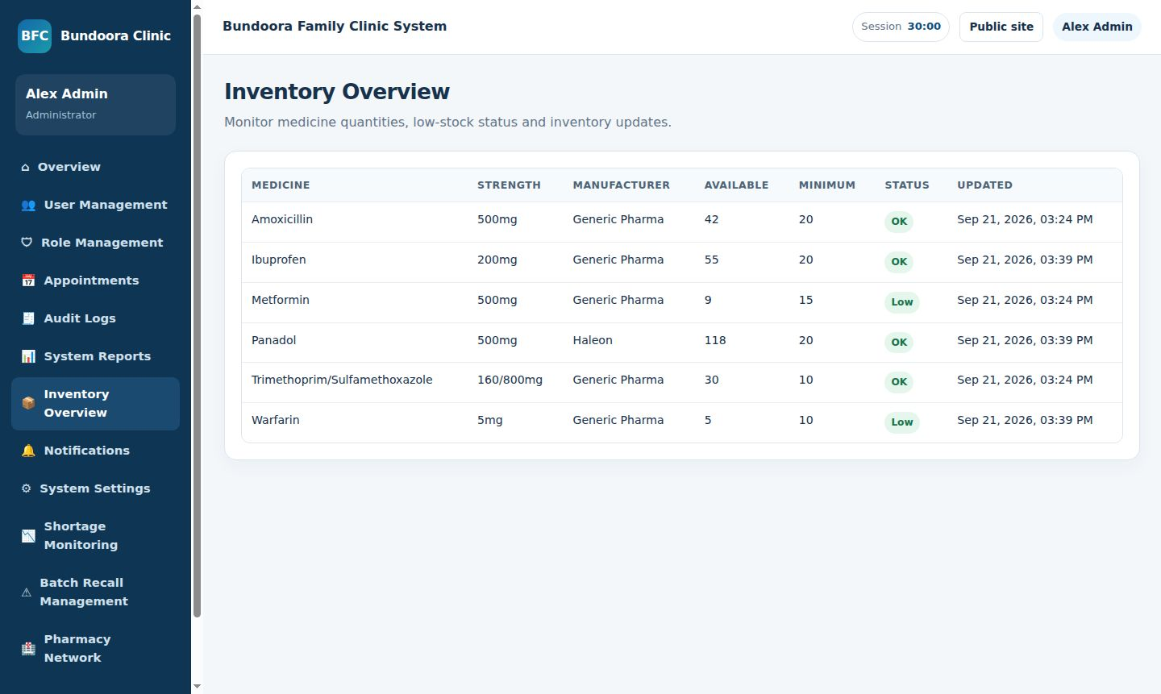
Figure 3.7.61: BFC-SEL-ADM-10 — Reports and CSV export (Pass) | Figure 3.7.62: BFC-SEL-ADM-11 — Inventory overview (Pass)

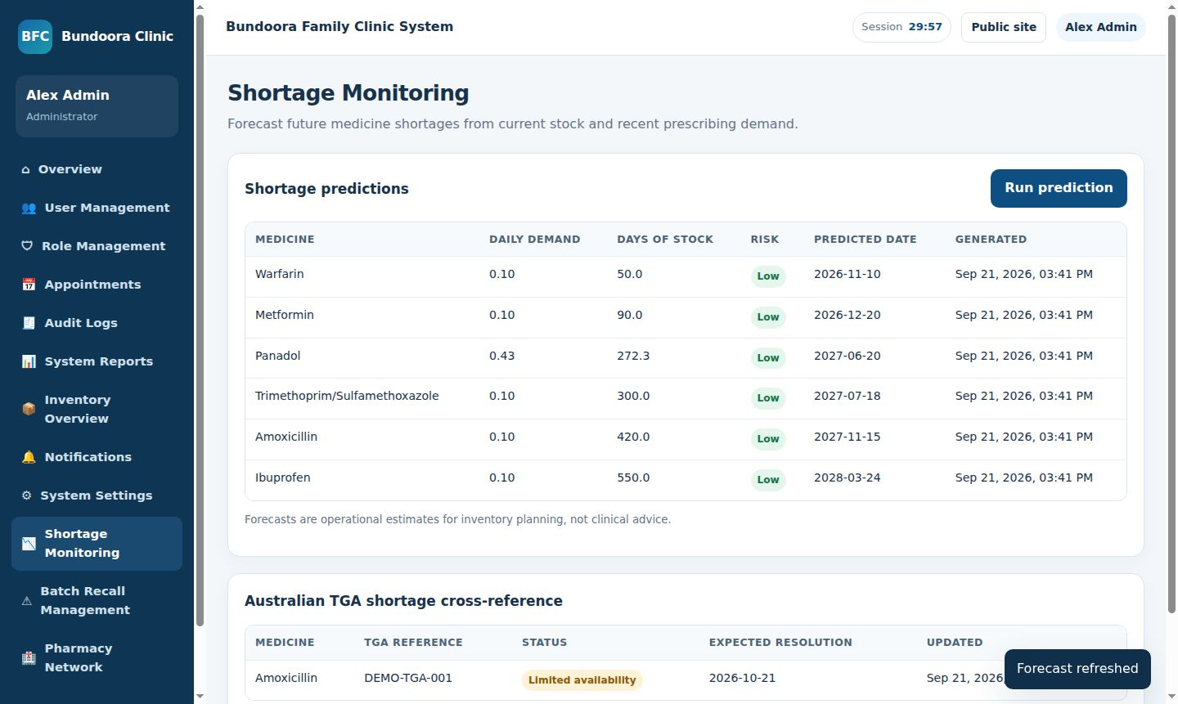 | 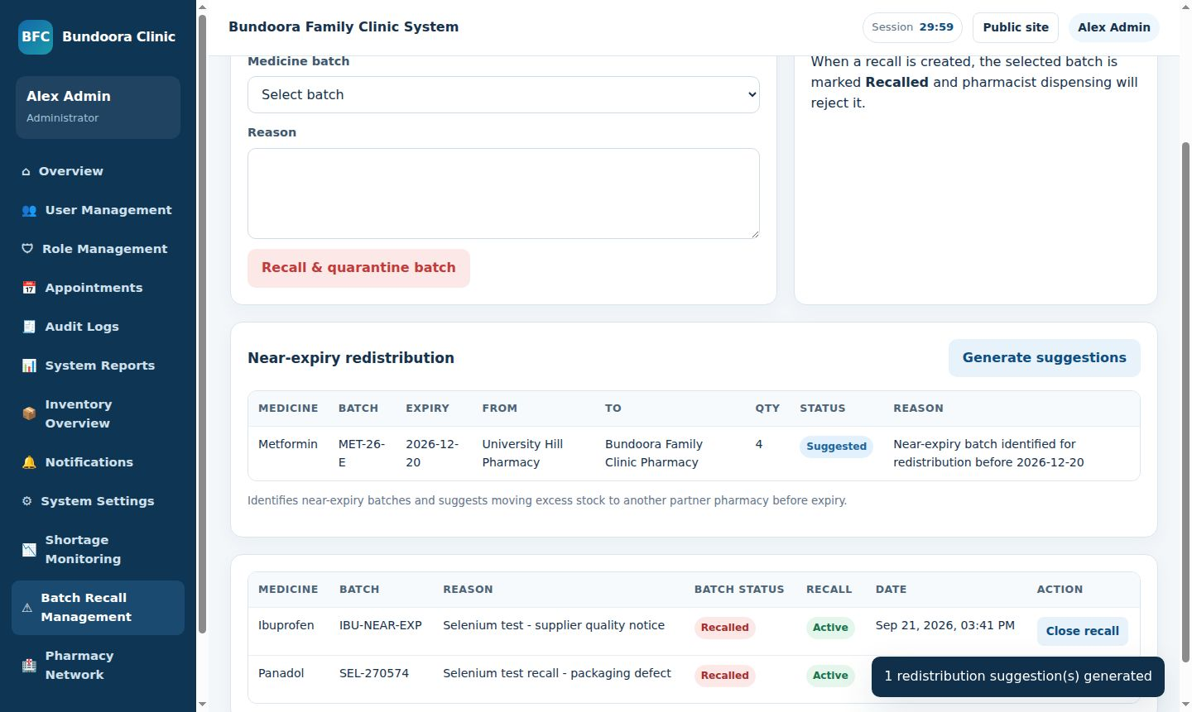
Figure 3.7.63: BFC-SEL-ADM-12 — Shortage prediction and TGA check (Pass) | Figure 3.7.64: BFC-SEL-ADM-13 — Batch recall and redistribution (Fail)

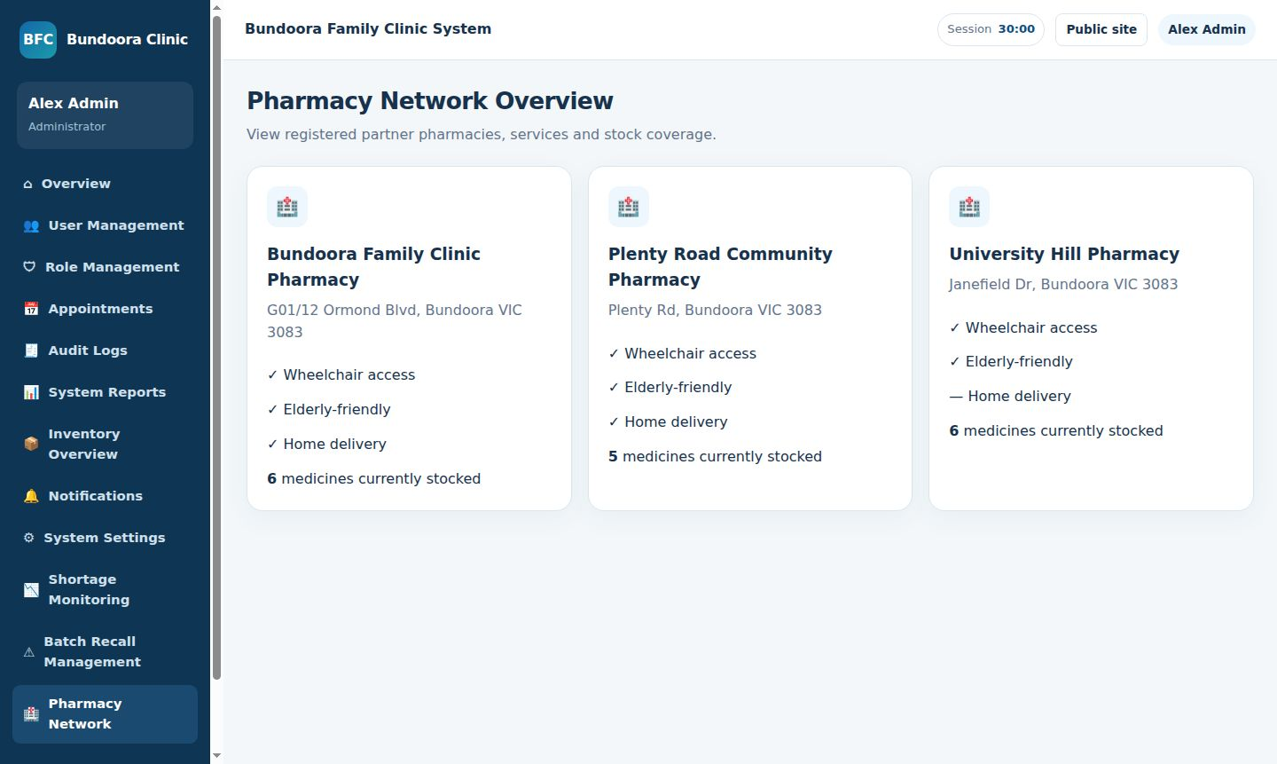 | 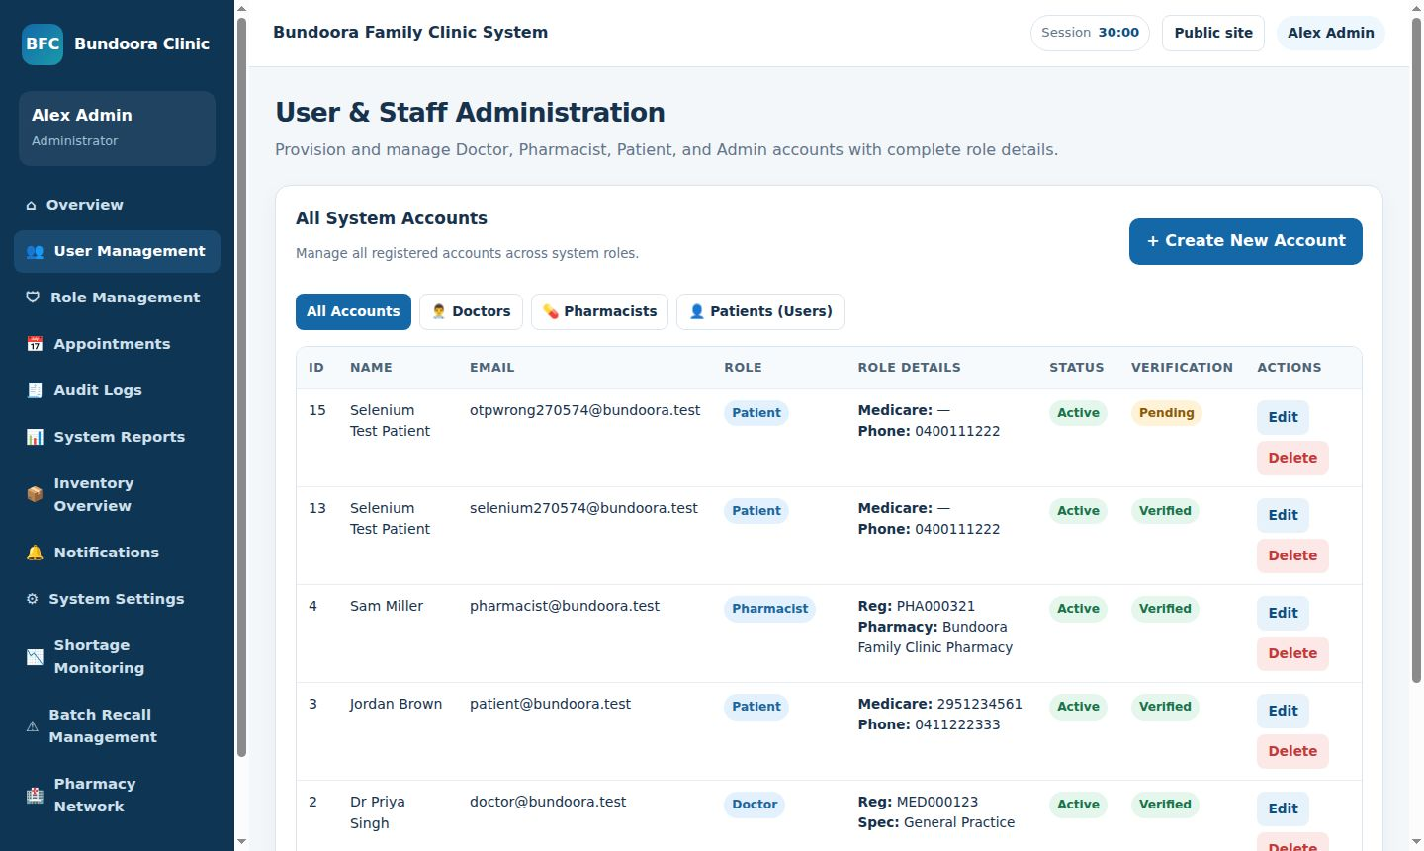
Figure 3.7.65: BFC-SEL-ADM-14 — Partner pharmacy network (Pass) | Figure 3.7.66: BFC-SEL-ADM-15 — Passwords stored hashed (Pass)

